 [Translated from Turkish to English - www.onlinedoctranslator.com](https://www.onlinedoctranslator.com/en/?utm_source=onlinedoctranslator&utm_medium=docx&utm_campaign=attribution)

**HOTEL RESERVATION**

**RN HOTEL**

CONTENTS

Project purpose ................................................................................ 3

Technologies I Use ........................................................................ 5

Database ........................................................................................ 6

Files ................................................................................................ 7

user-side operation ........................................................................ 8

Home Page ........................................................................................ 8

Rooms Page ................................................................................ 16

Room Features ................................................................................ 23

Contact ...................................................................................... 24

About Us ................................................................................ 24

Admin Panel ............................................ ........................ 25

Admin Login Page ................................................................ 25

Dashboard ............................................ ........................ 25

Reservations ........................................................................ 26

Users ........................................................................................ 30

User Queries ............................................................................... 30

Rating ................................................................................ 31

Rooms ................................................................................................ 32

Room features ................................................................................ 33

Carousel ............................................ ................................... 34

Settings ................................................................................................ 35

Most Important Codes ........................................................................ 41

Website Link ............................................ ........................ 48

**Project Purpose:**

With the advancement of technology and high-speed internet, the traveler can book a hotel where they can benefit from the idea of ​​suitable places to choose the best in terms of price and services provided. The site allows guests to plan their dates and length of stay and choose the room and extras at the time of booking. The latest systems allow customers to choose what extras can be put in their room upon arrival.

**User Actions:**

* Book a hotel room
* Check available rooms
* Manage reservations - change or cancel reservations
* Review and rate the booked rooms and their services
* User login and registration
* Profile Management

**Admin Actions:**

* Room management - add, delete or update
* Reservation management - Confirm, view, delete or update a reservation
* User management – ​​show, add or delete
* Add, change or delete room features
* Add, change or delete room service
* shut down website
* Review and rating management

**Technologies I Use:**

* HTML, CSS, BOOTSTRAP, Ajax AND PHP





**Database:**

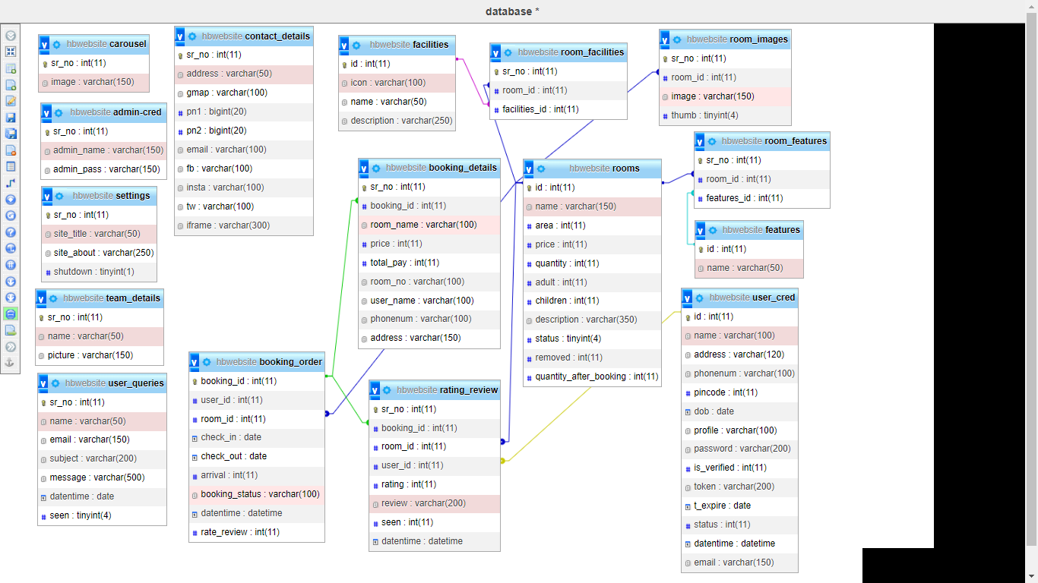

**Files :**

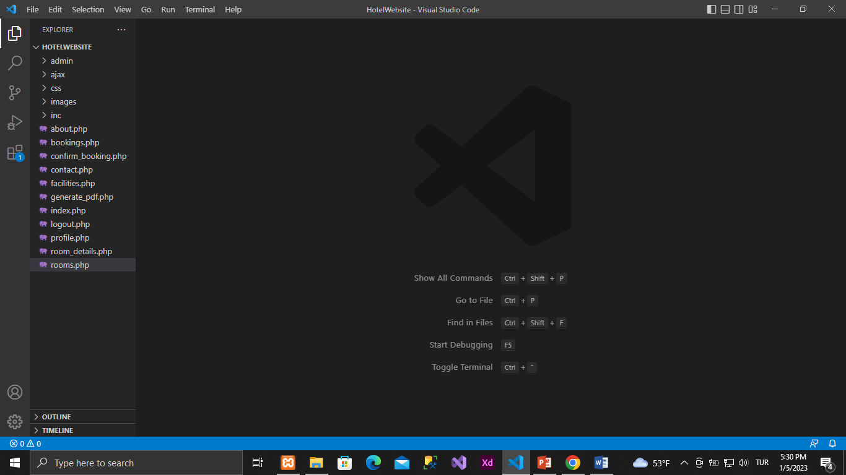 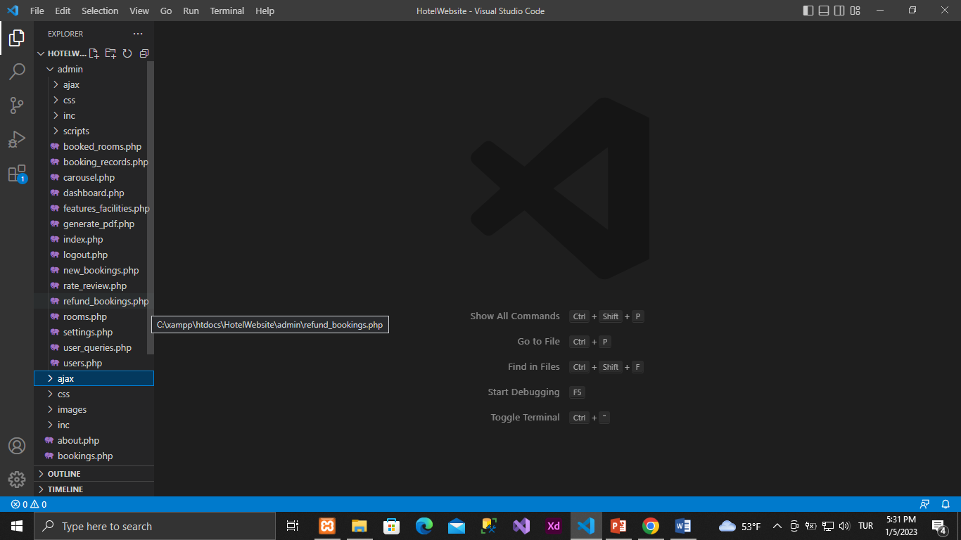

All files are in Admin folder

**user side operation:**

1. Home Page

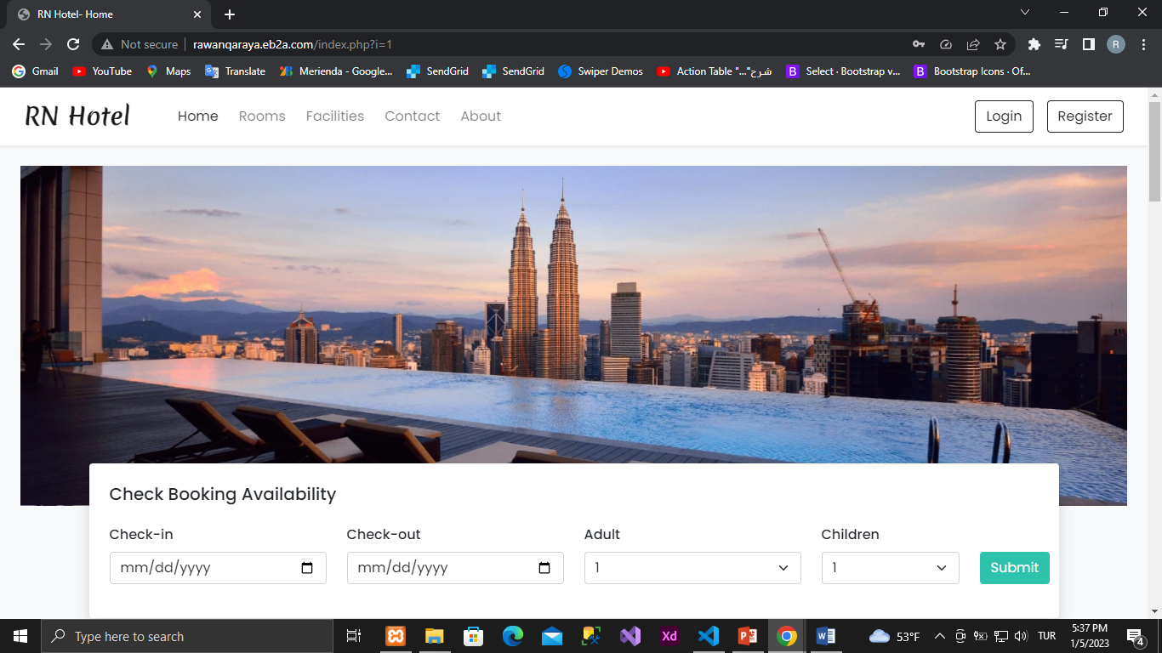

Check booking availability🡪To perform filter operations

The result is like this

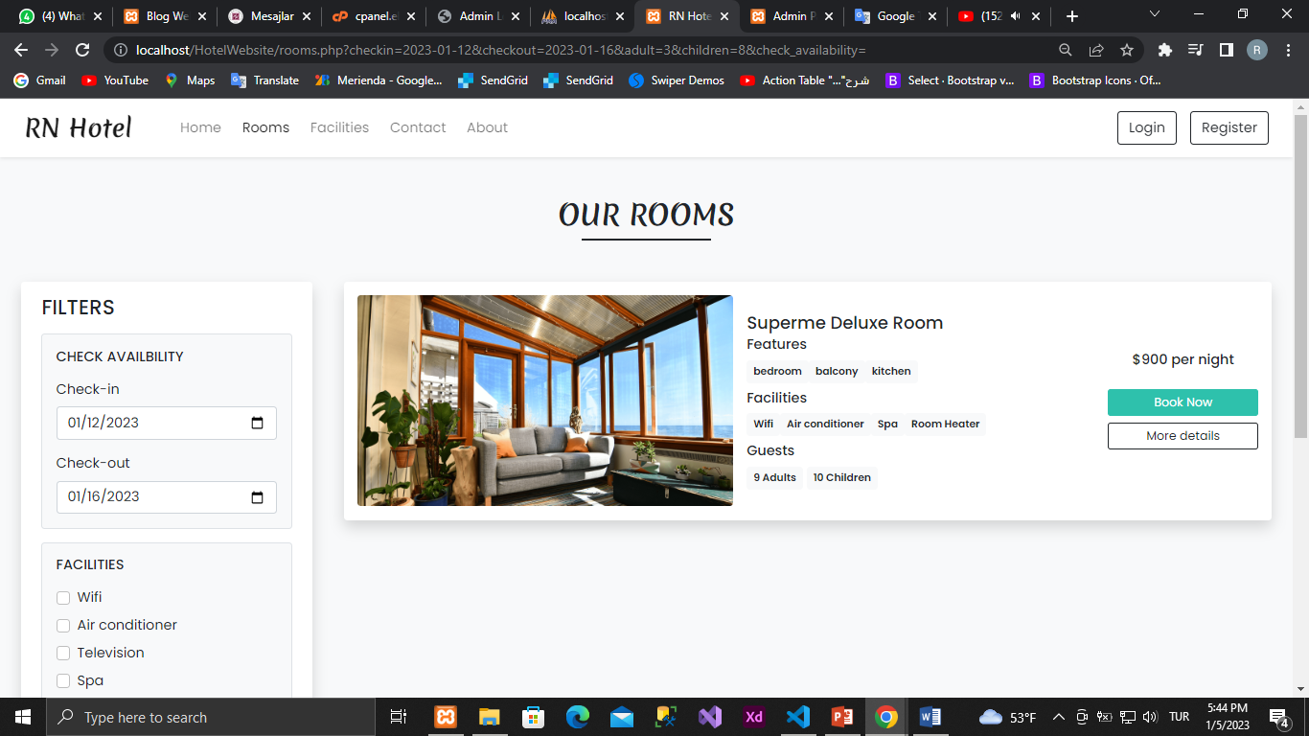

Some rooms

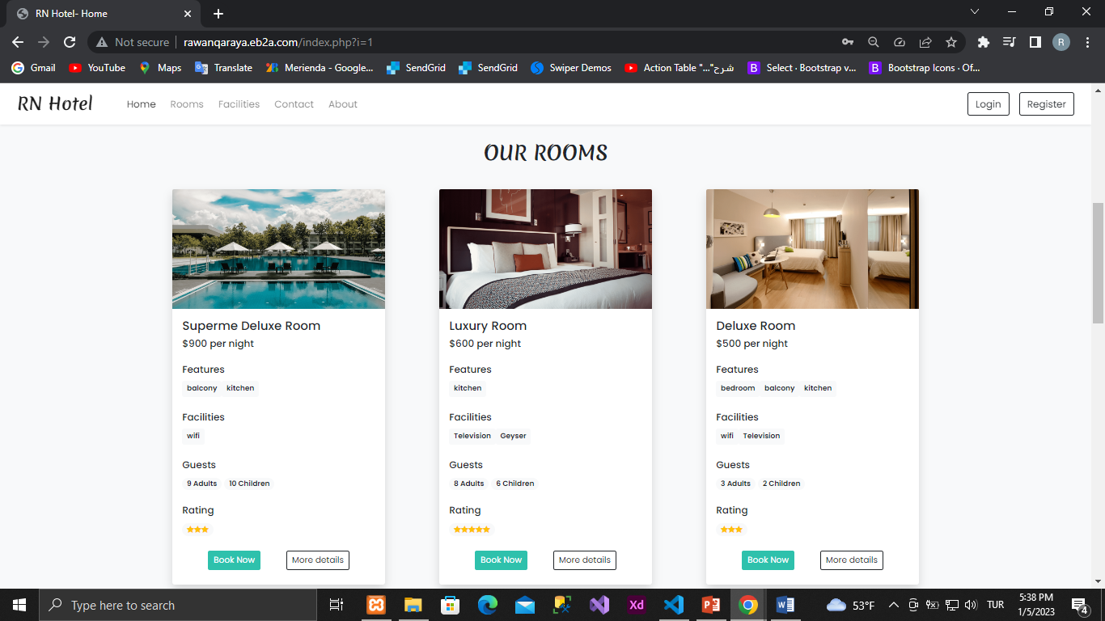

Rooms features

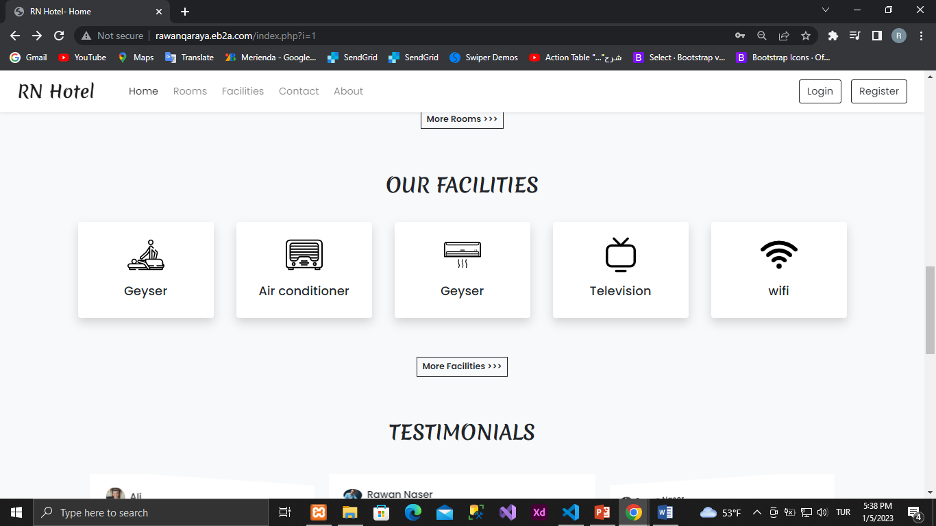

Ratings and Reviews

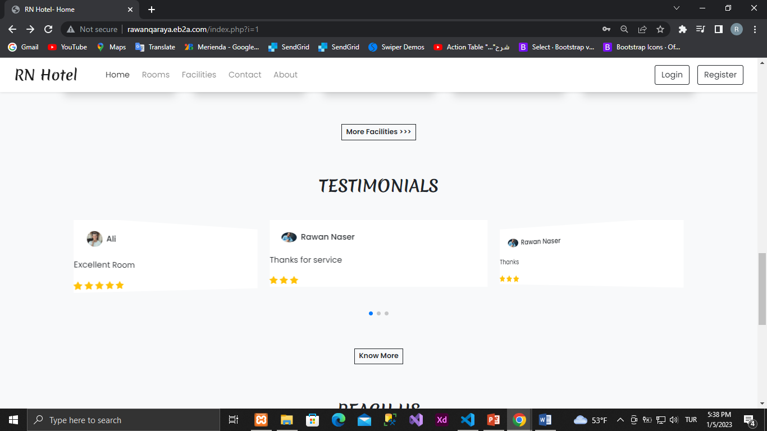

Communication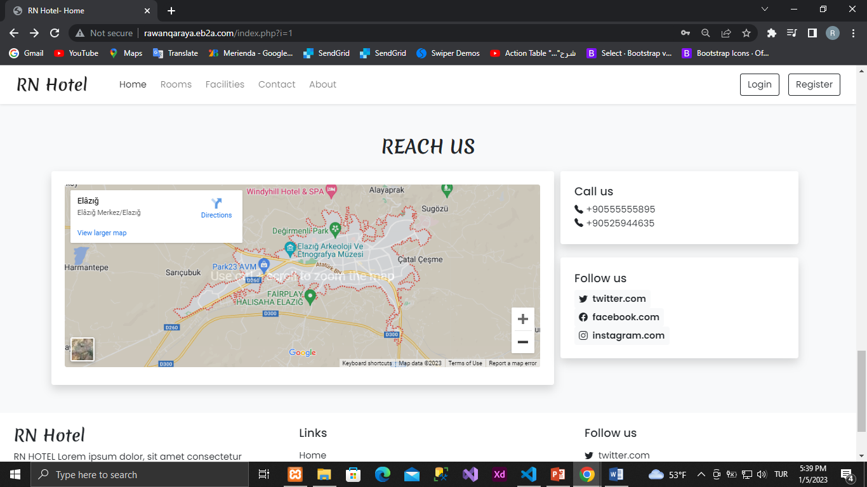

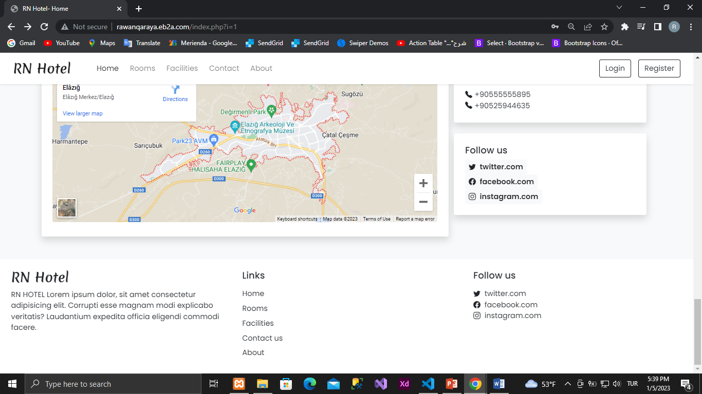

Sign in

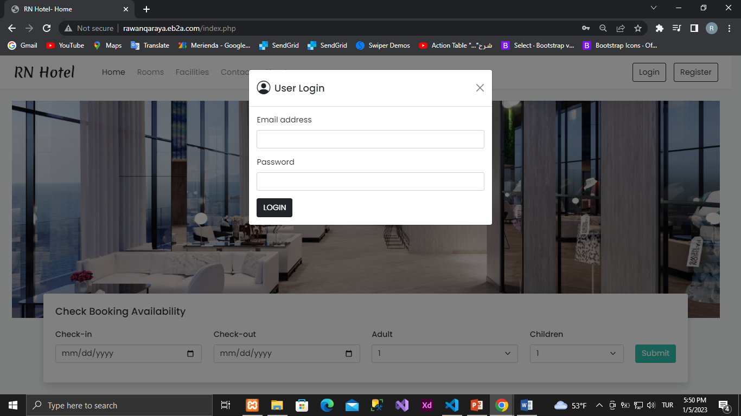

Sign up

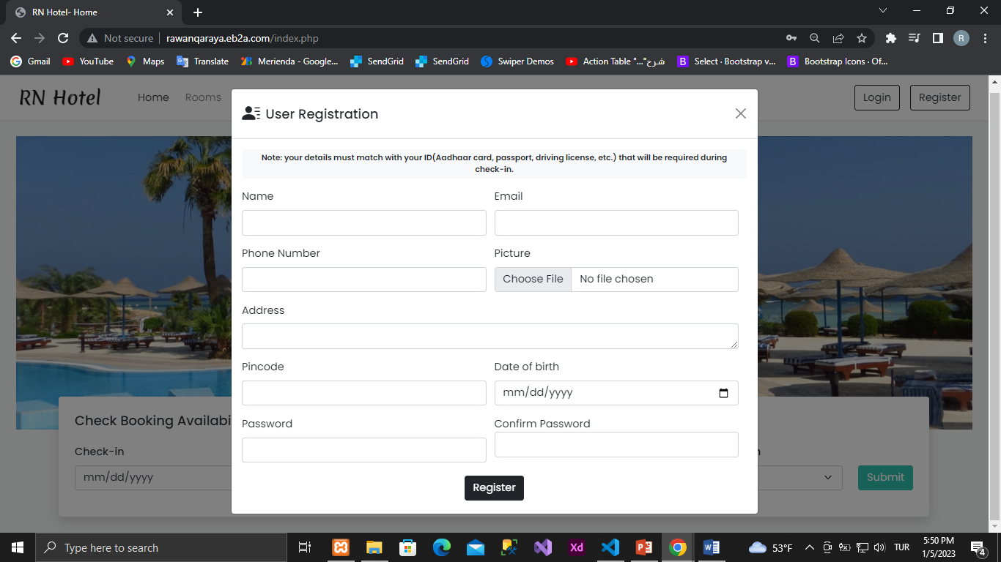

an email and a phone number for each user when registering.

Duplicate emails for multiple users are not allowed.

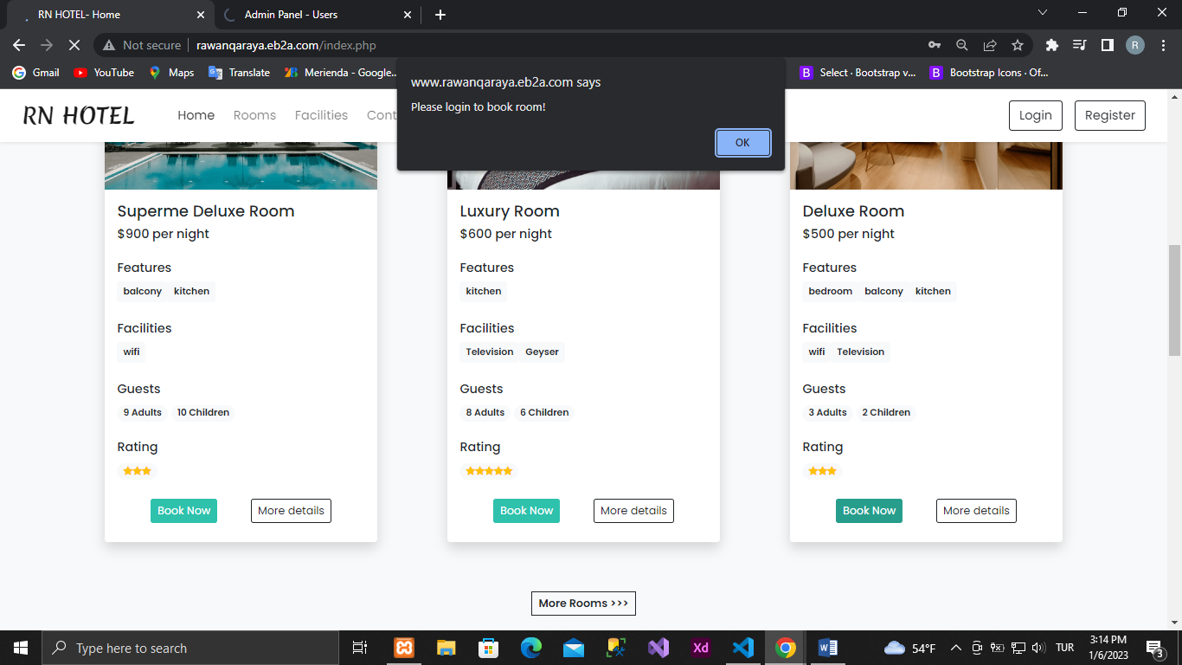

We must log in before booking a room.

After logging in

We can see and change user information on the profile.

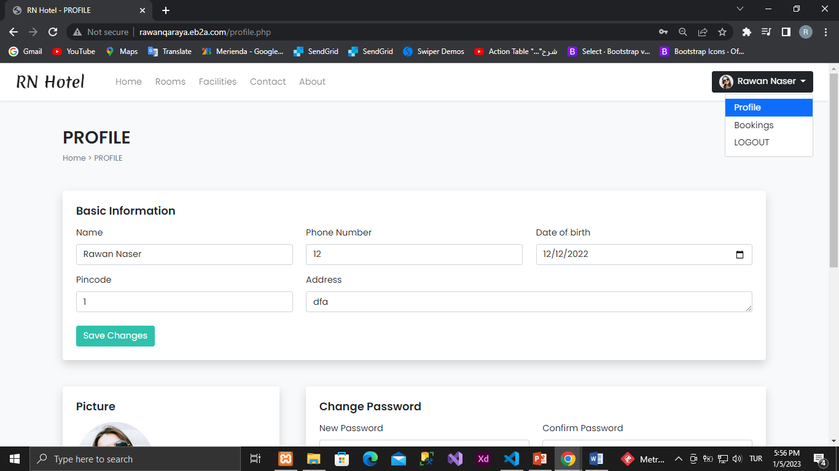

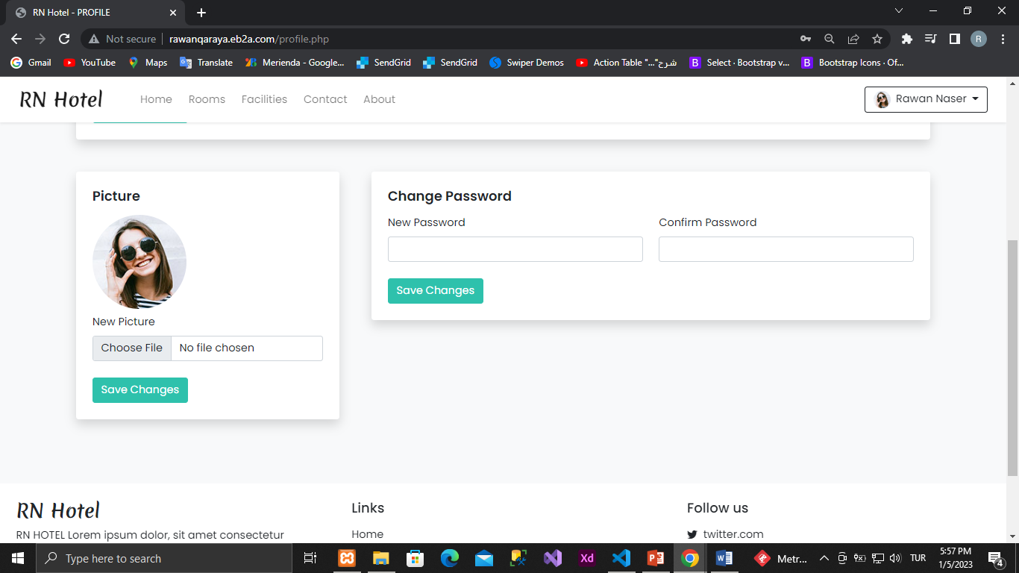

We can change or cancel reservations on Bookings

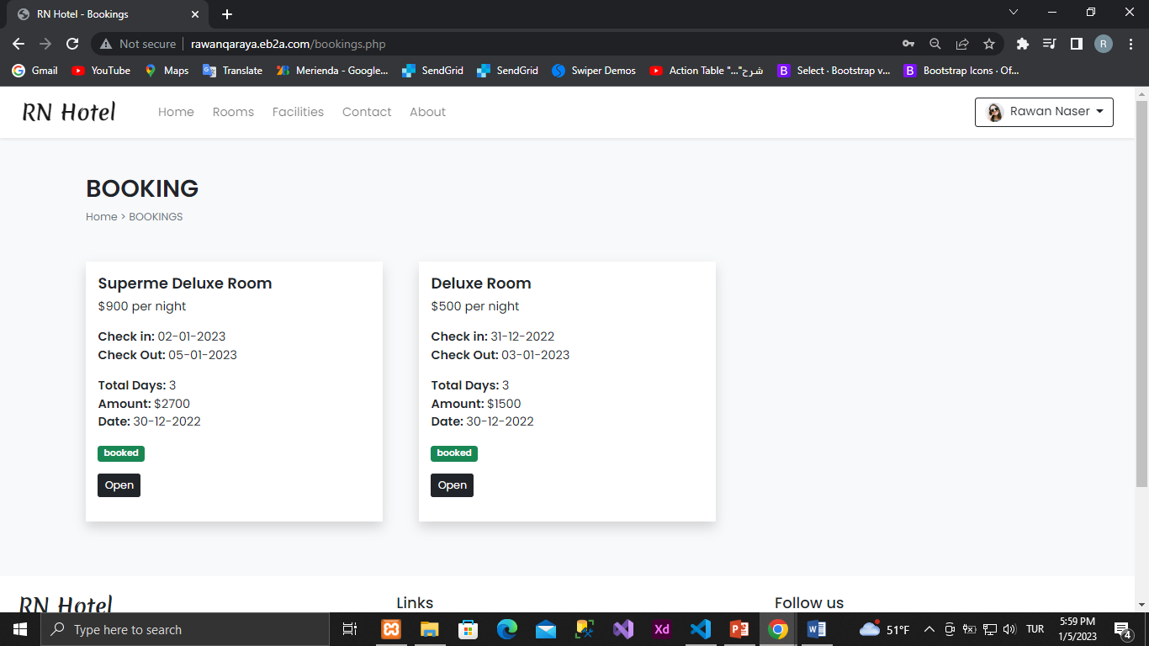

When you click on the Open button, the reservation details will be displayed.

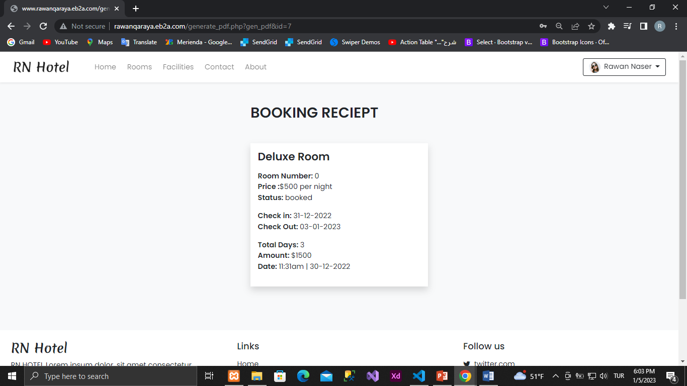

We will select logout to log out

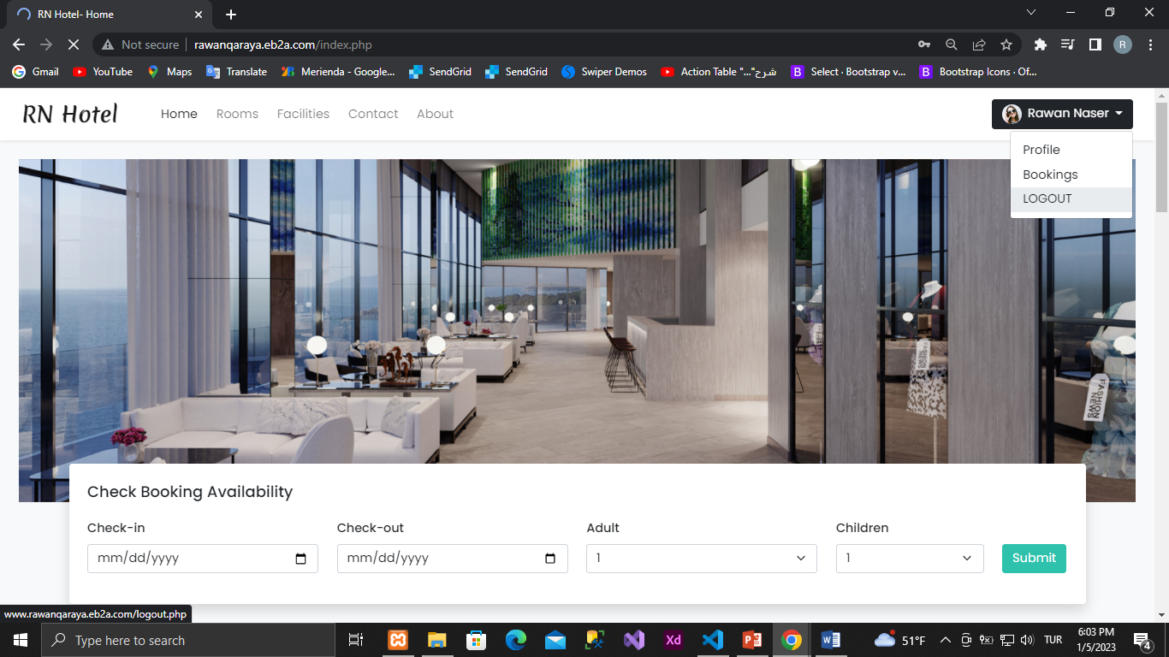

1. Rooms Page

Showing rooms and filtering

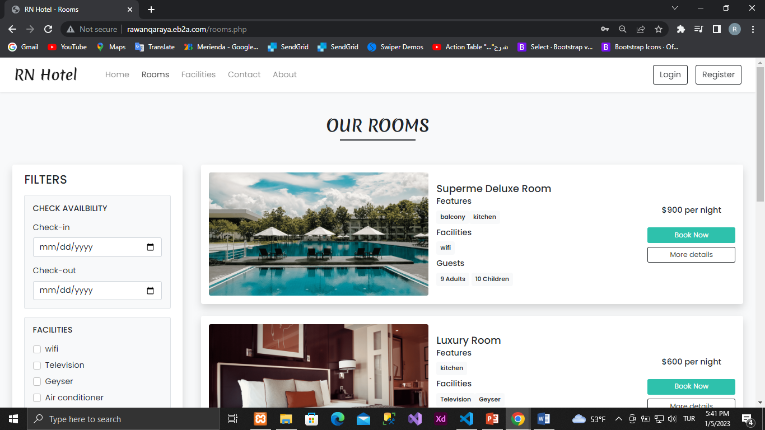

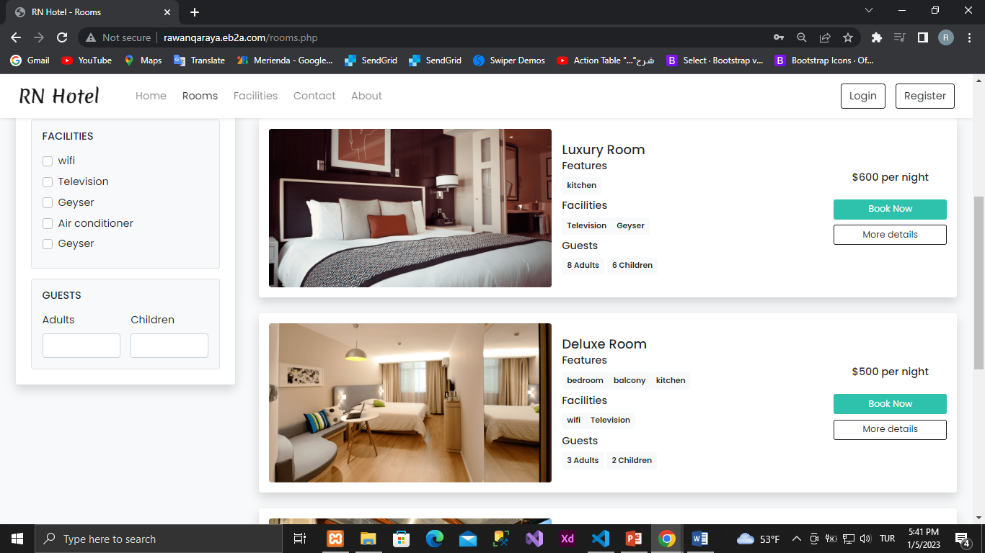

After filtering

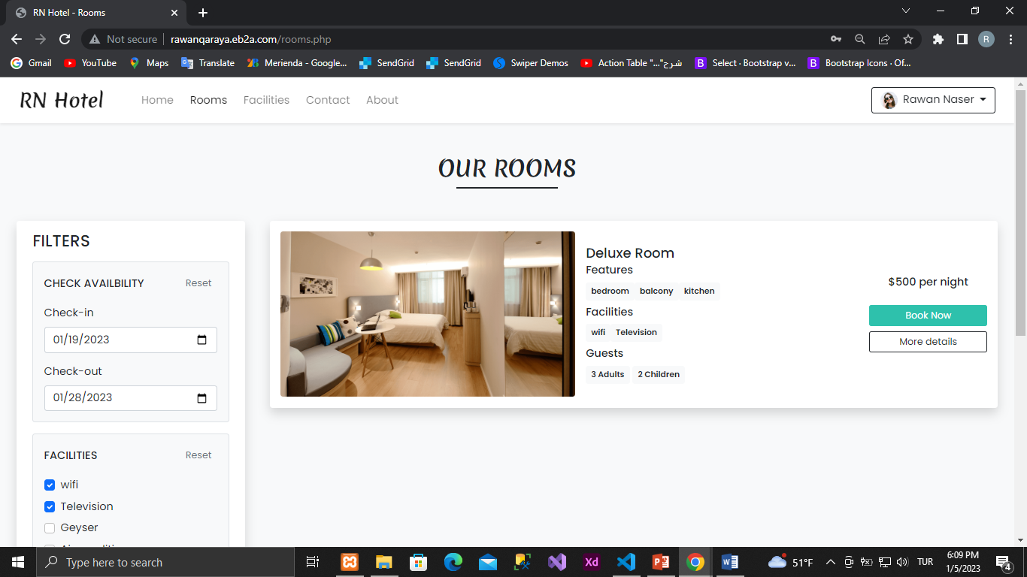

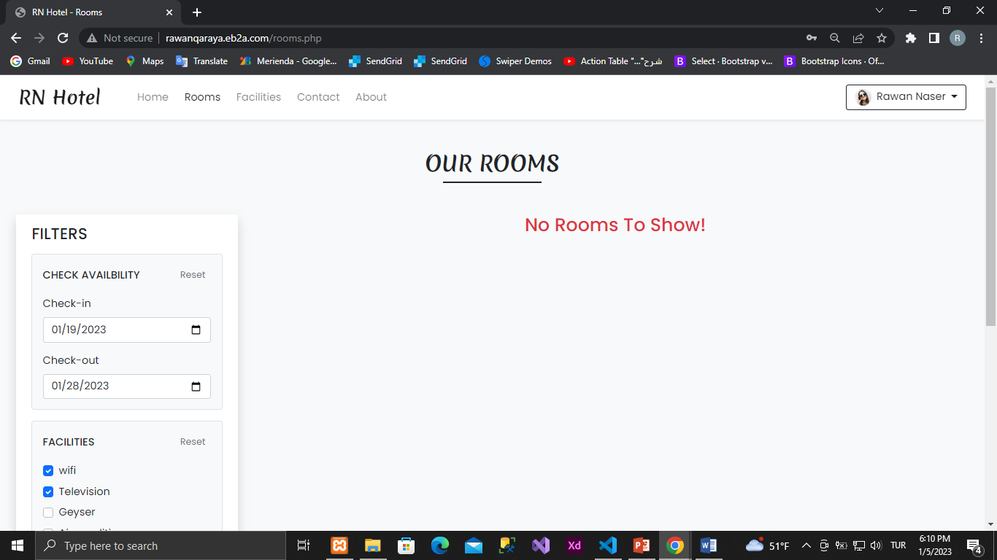

When you click on the More details button

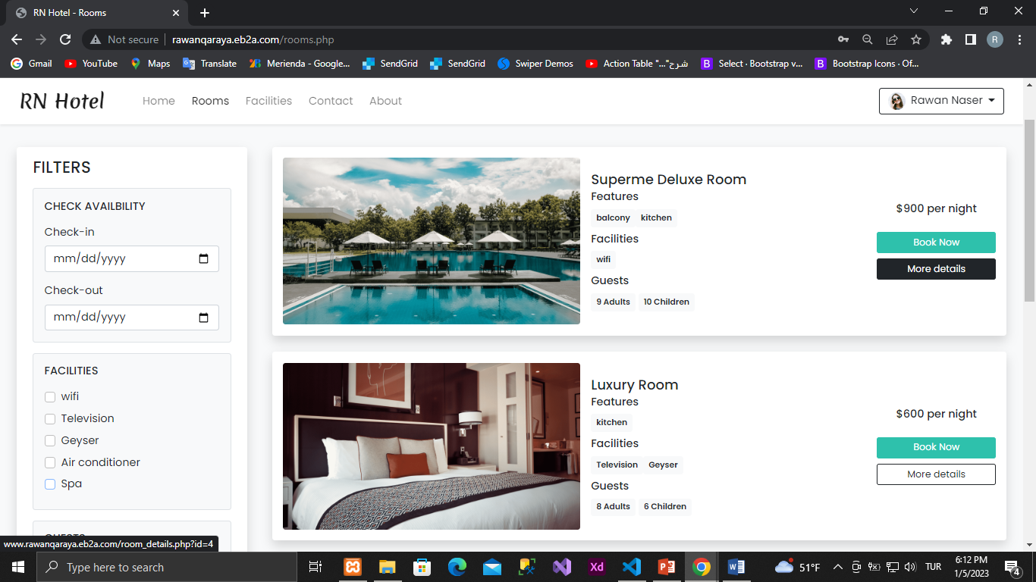

This is the result. The room details will show

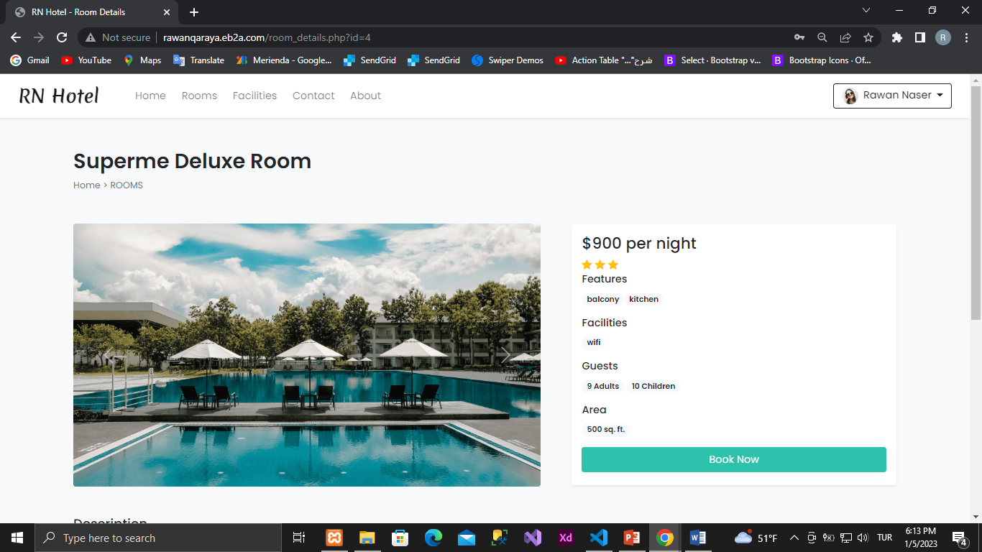

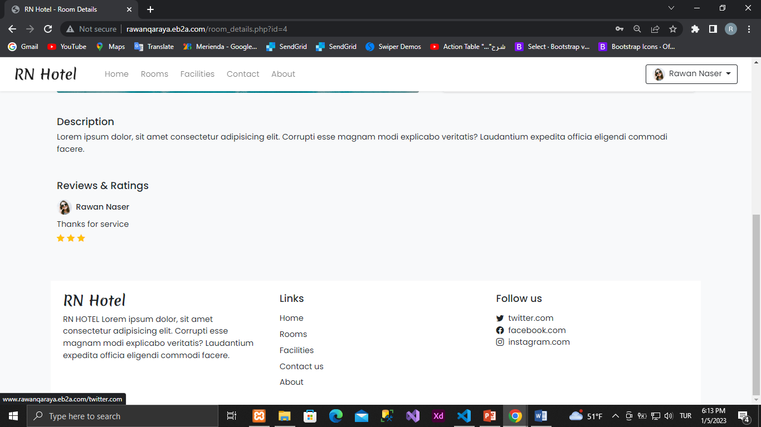

When you click on the Book Now button,

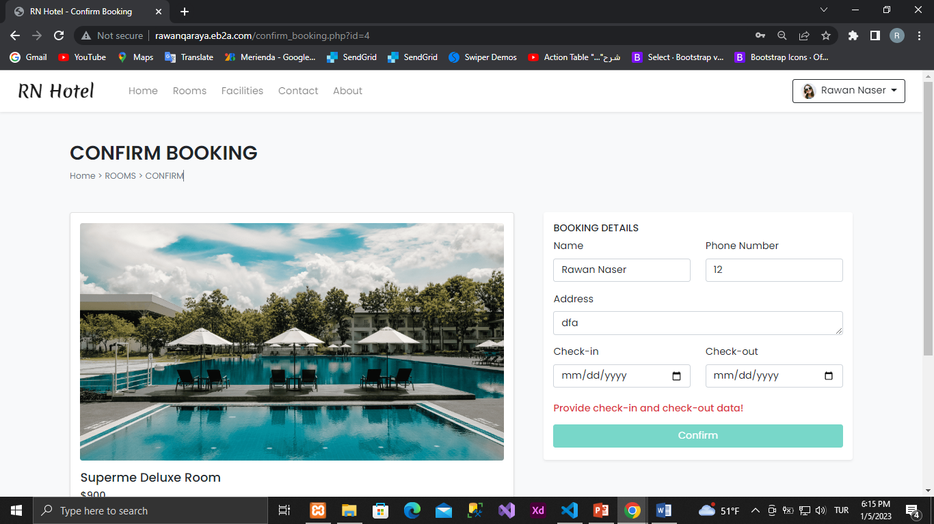

If we select the wrong date, it will show an error message.

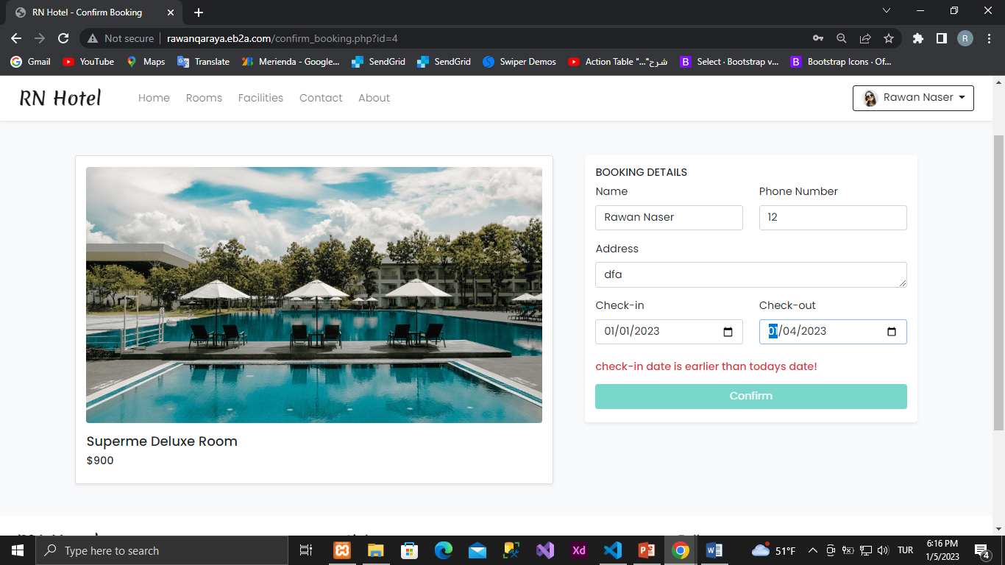

If there are no available rooms (i.e. all rooms are booked in the same time period) this message will be displayed.

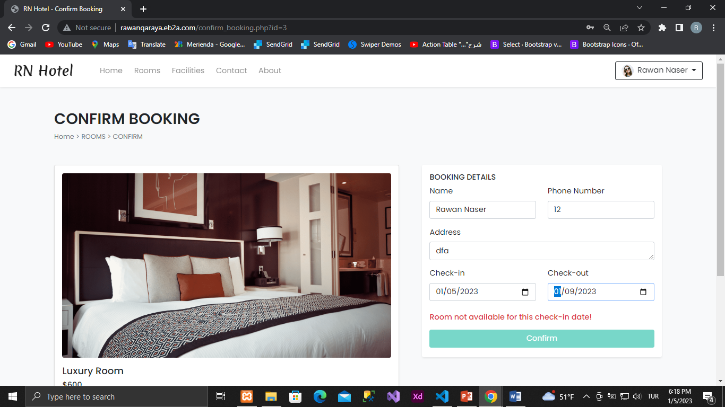

We can cancel the reservation from here

Waiting for admin to approve the reservation

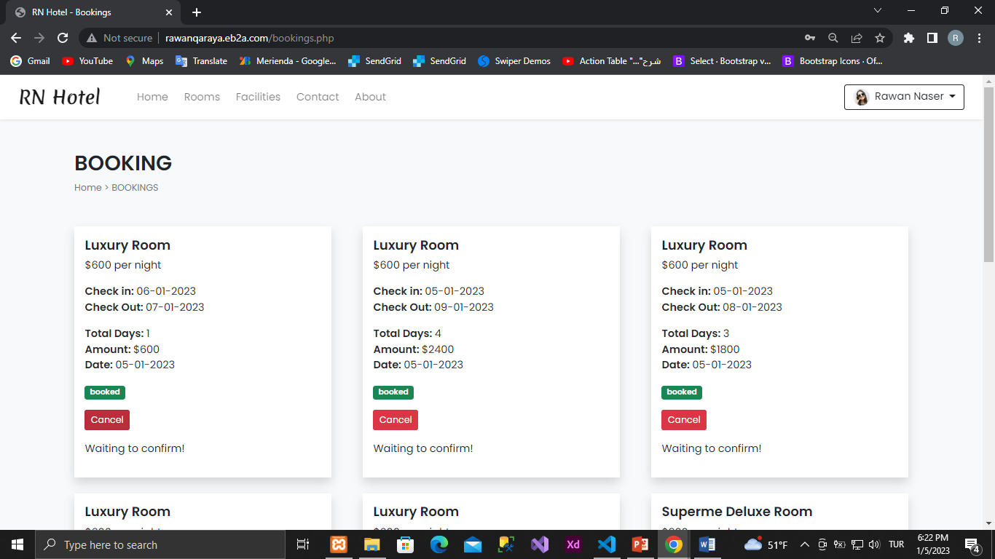

Conclusion

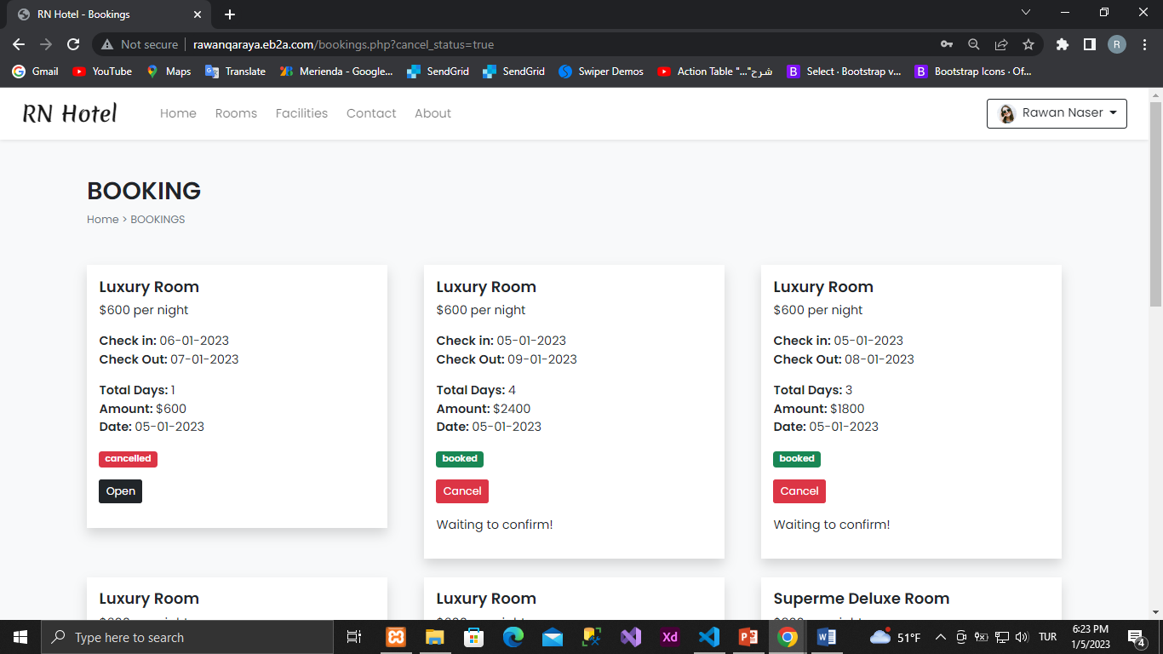

After the admin confirms the reservation, the user can rate the room.

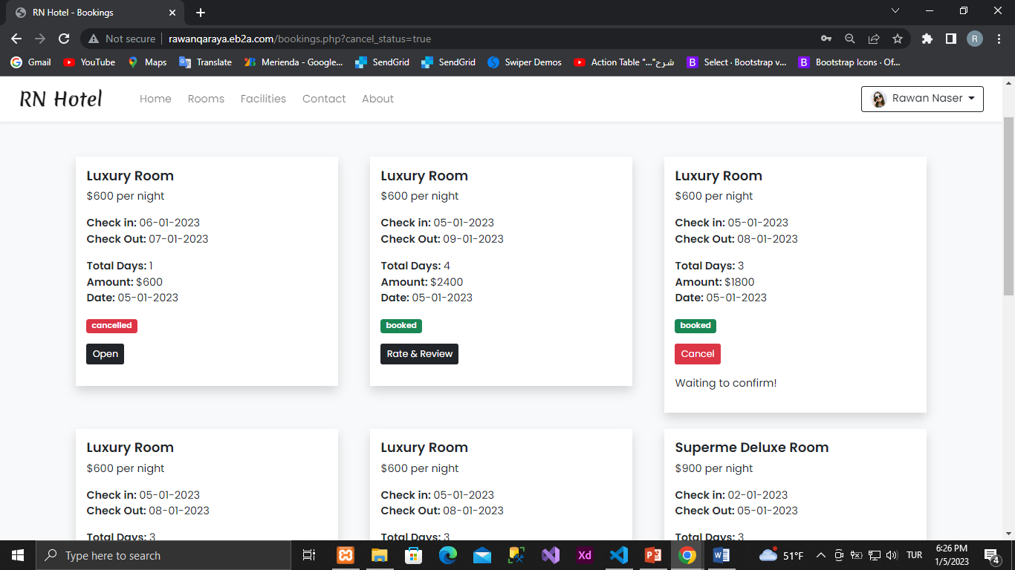

When you click on the rate and review button

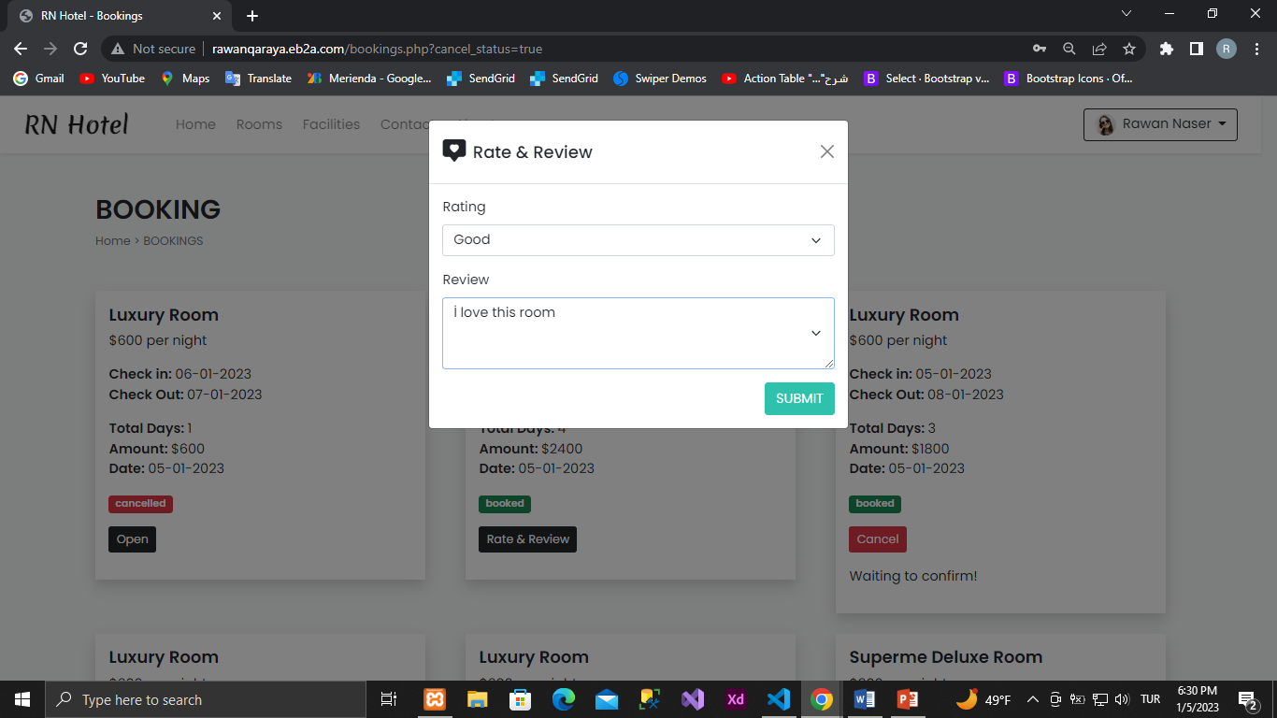

1. Room features

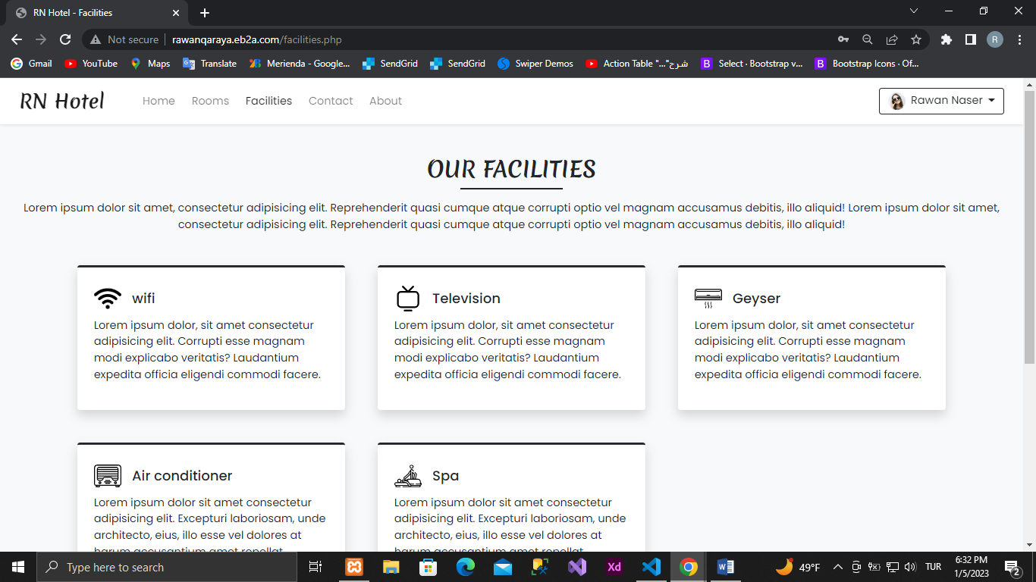

1. Communication

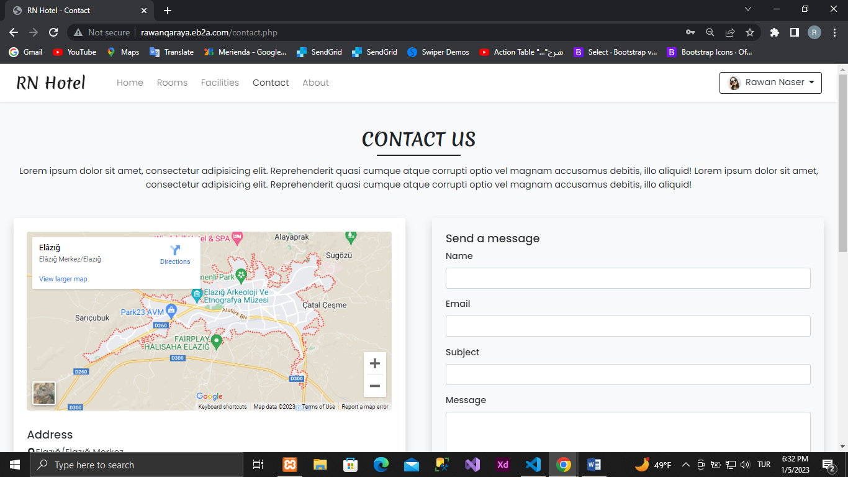

1. About Us

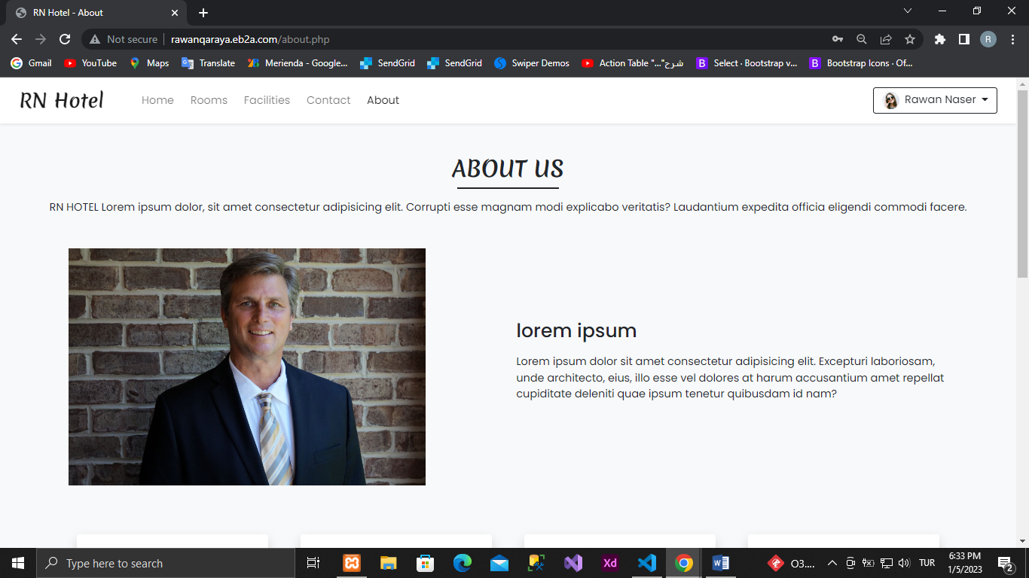

**Admin Panel:**

1. Admin Login Page

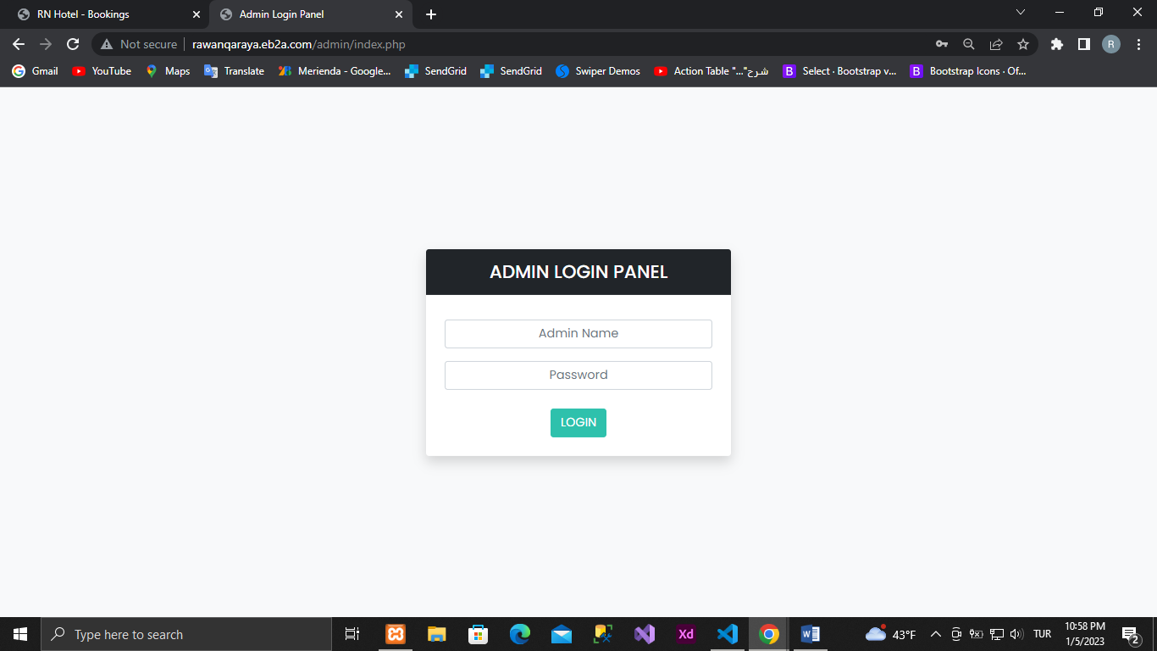

1. Dashboard

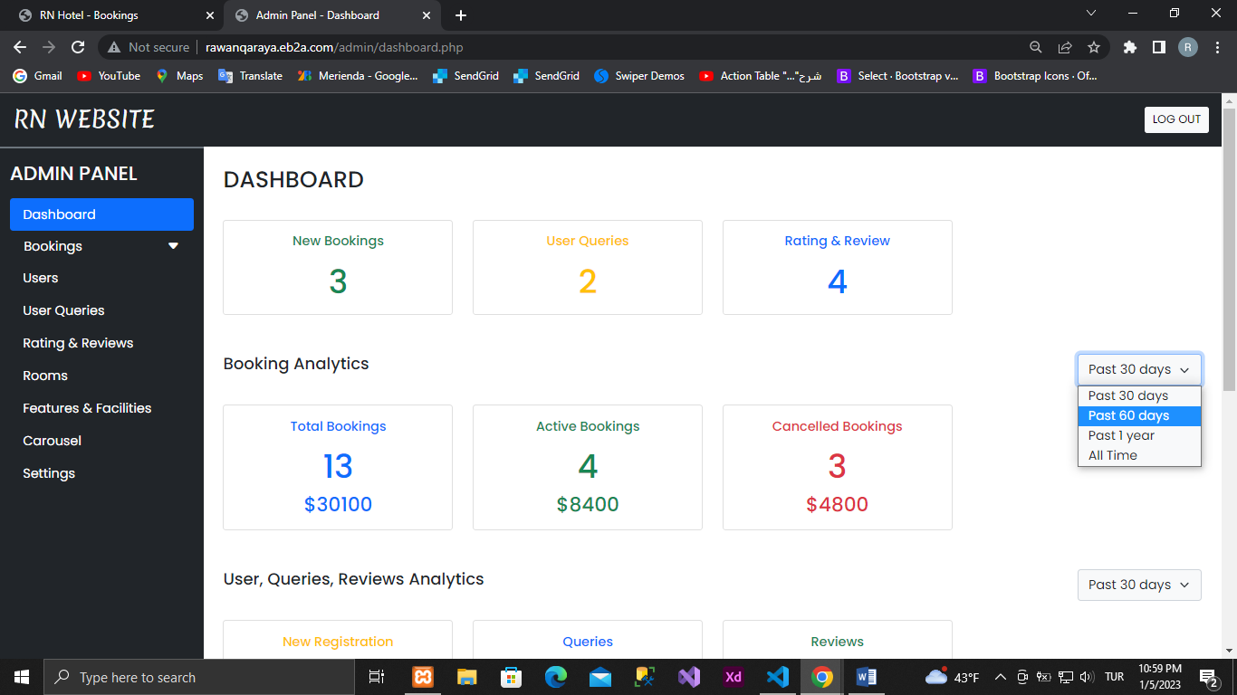

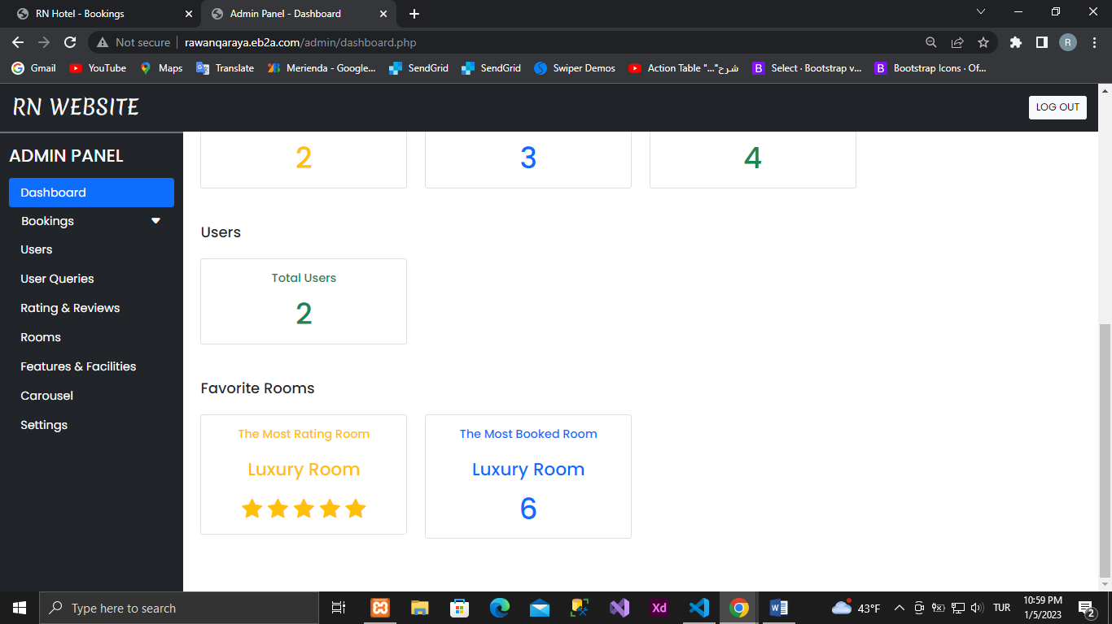

1. Reservations

Showing new bookings

to confirm the reservation

to cancel a reservation

for search

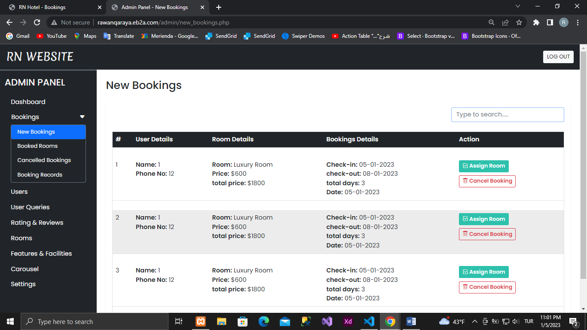

shows reserved rooms

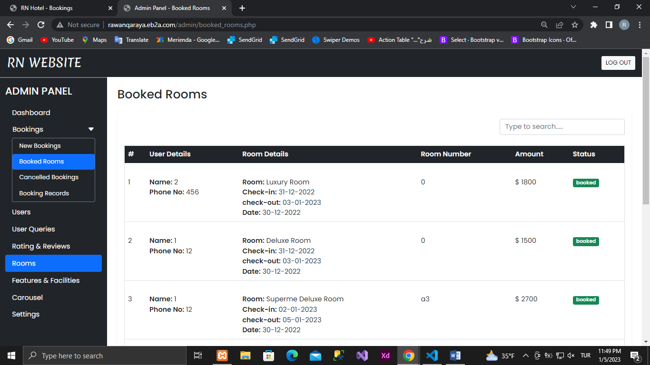

shows cancelled rooms

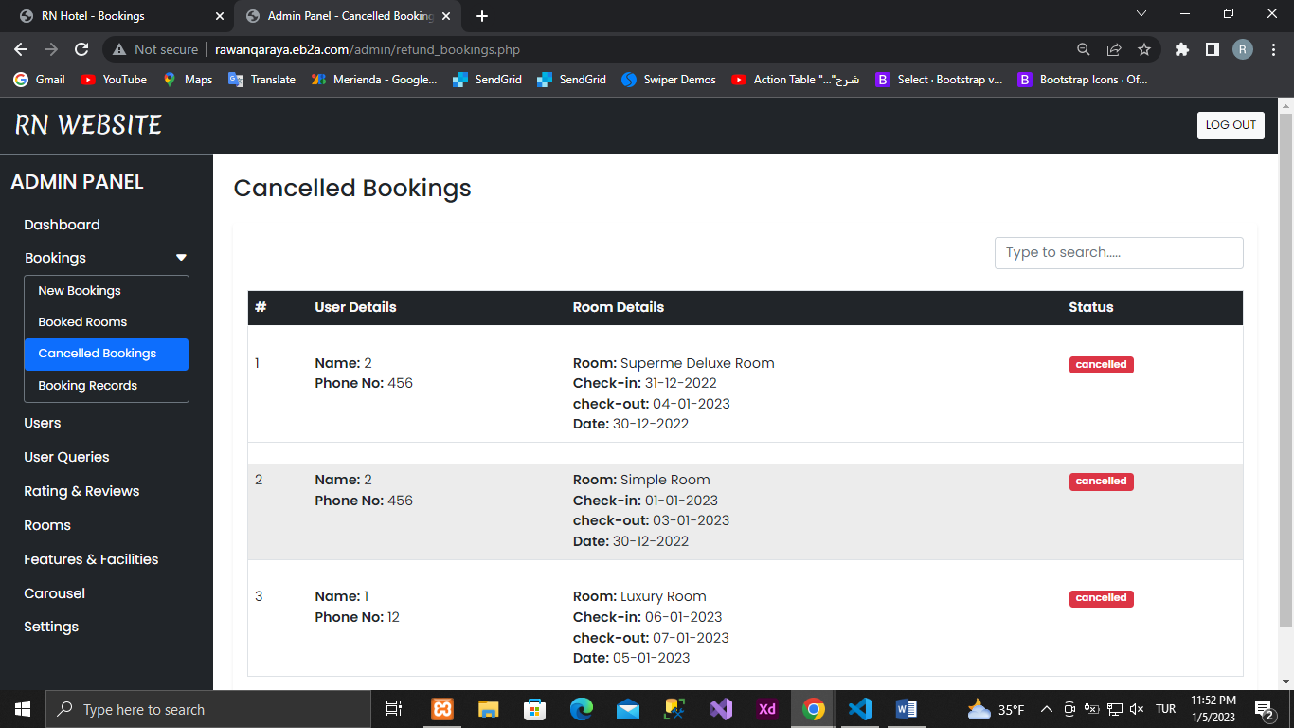

Booking records show

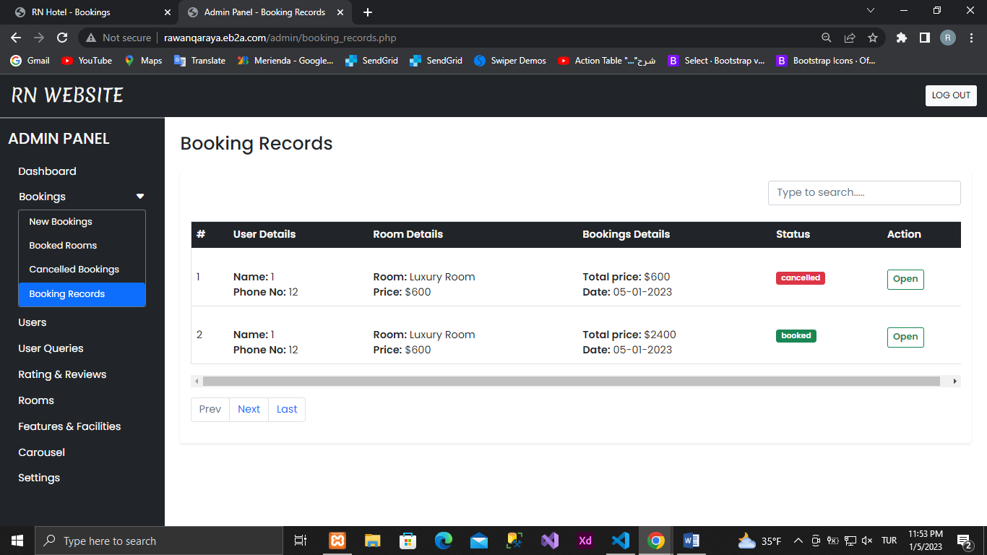

When you click Open

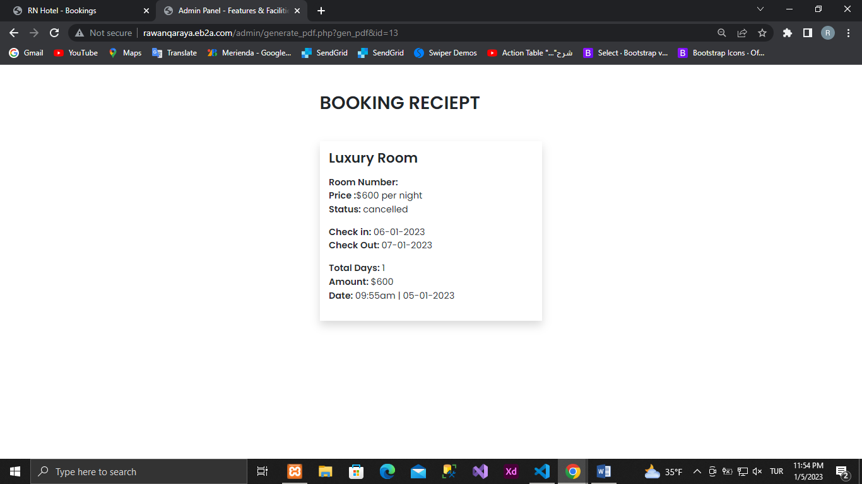

1. Users  
     
   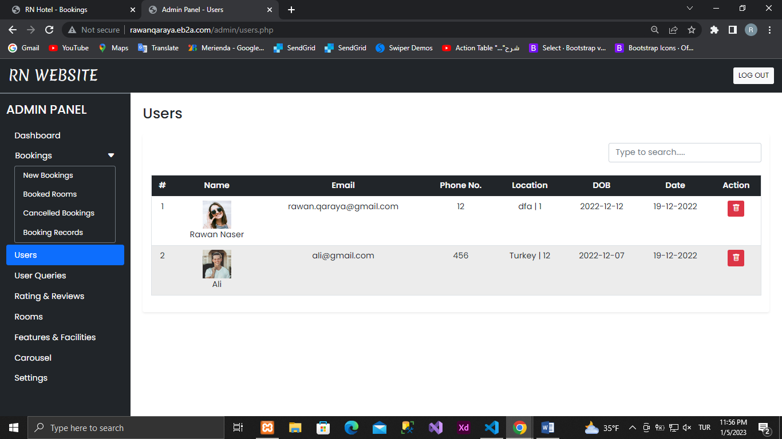

To delete

Mark as read

We can delete a user from here

1. User queries  
     
   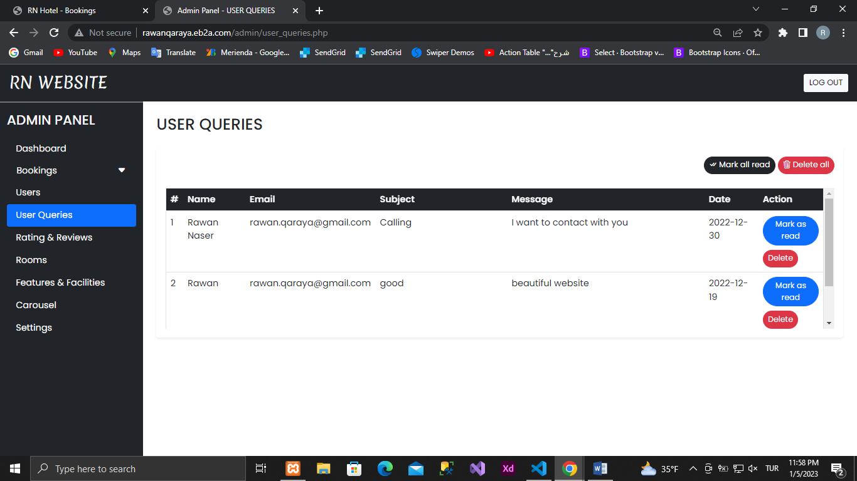
2. Ratings and reviews  
     
   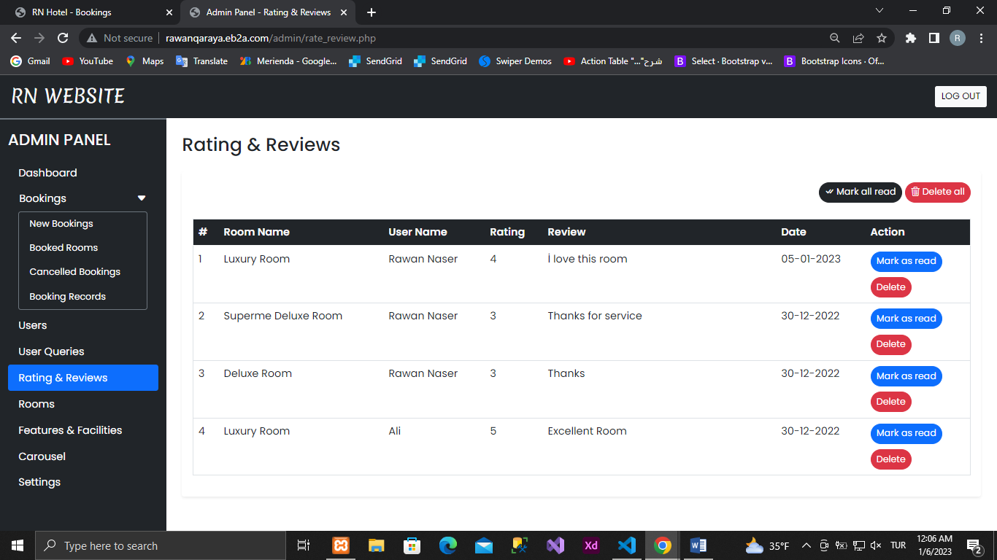

To delete

Mark as read

1. Rooms  
     
     
     
   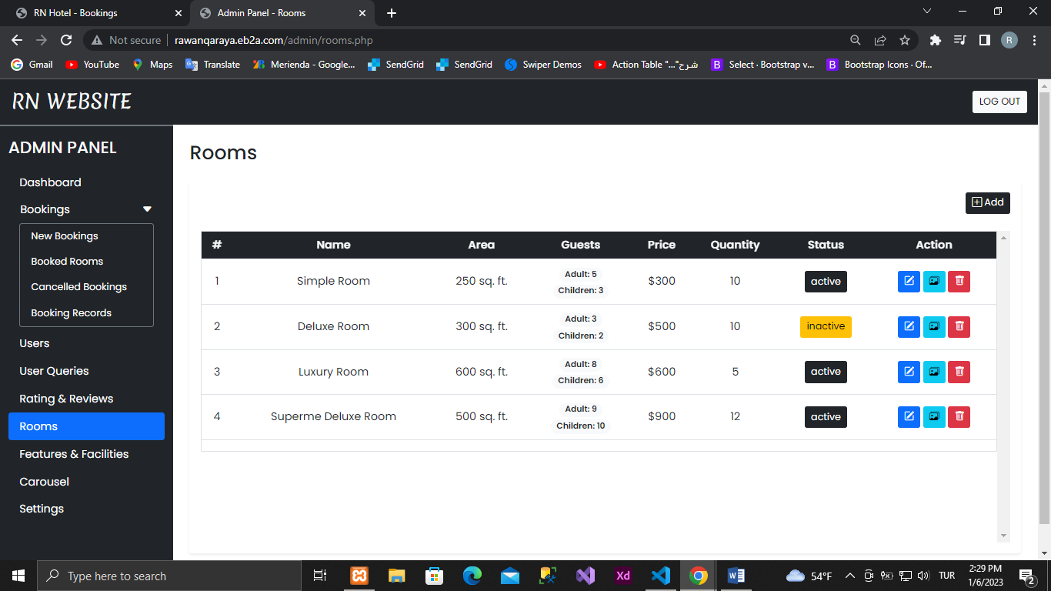  
   room picture upload  
   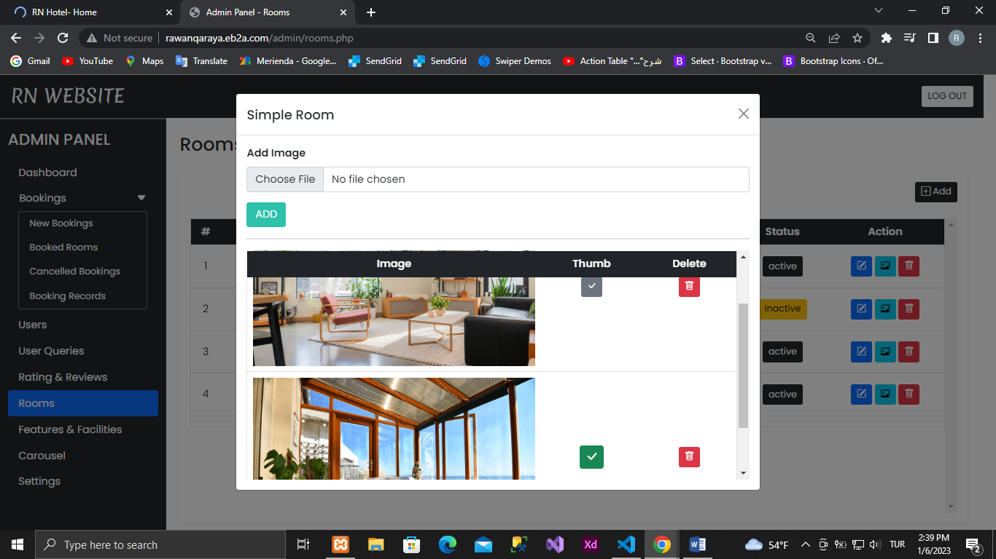

If the image is a thumbnail, that image will be displayed on the home page.

To delete the room

To upload a room image

To Update the Room

If the room is active it will show on the home page. If it is inactive it will not show on the home page.

1. Room Features  
   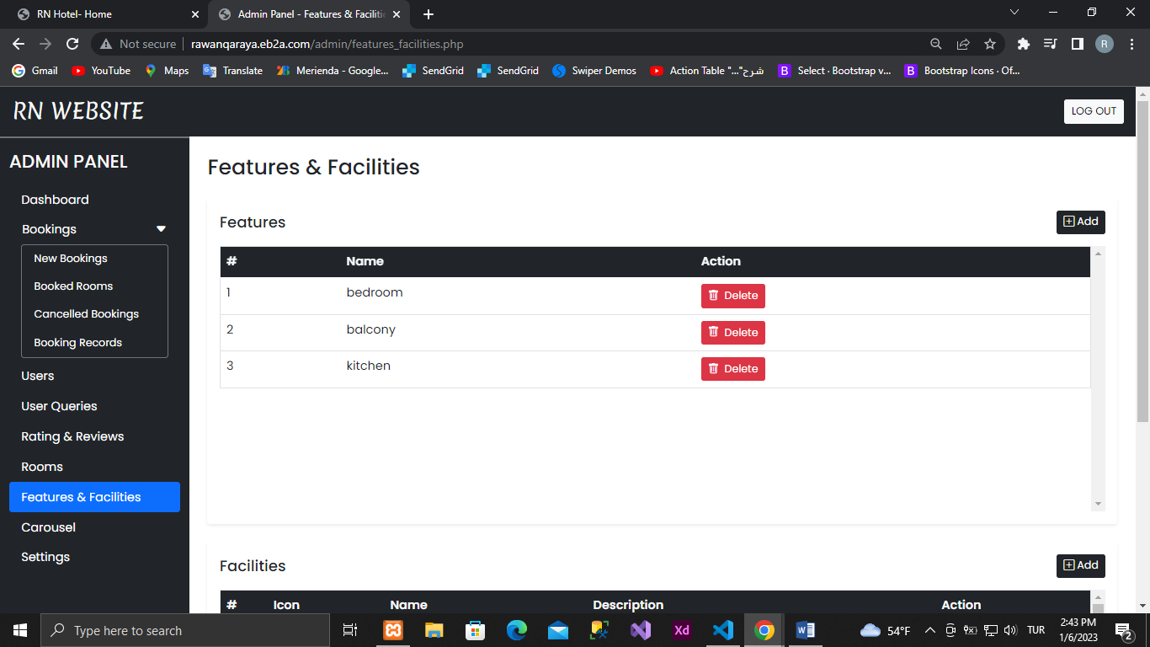

To add

If this feature is in a room, it will not be deleted.

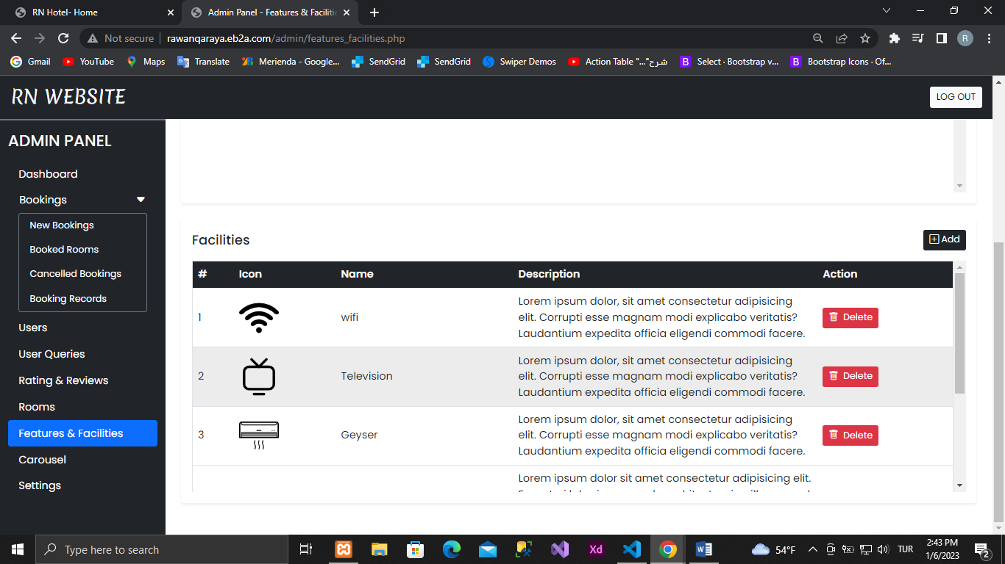

1. Carousel  
   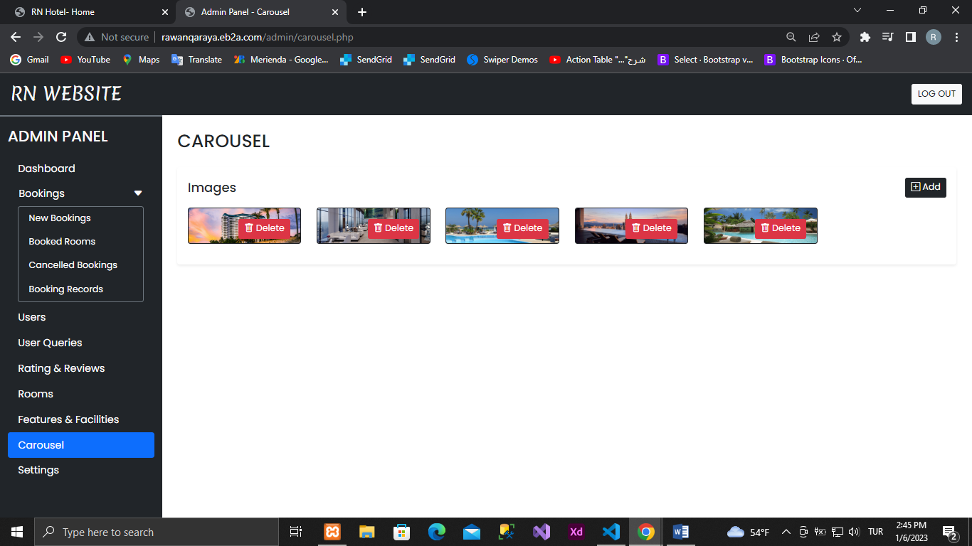

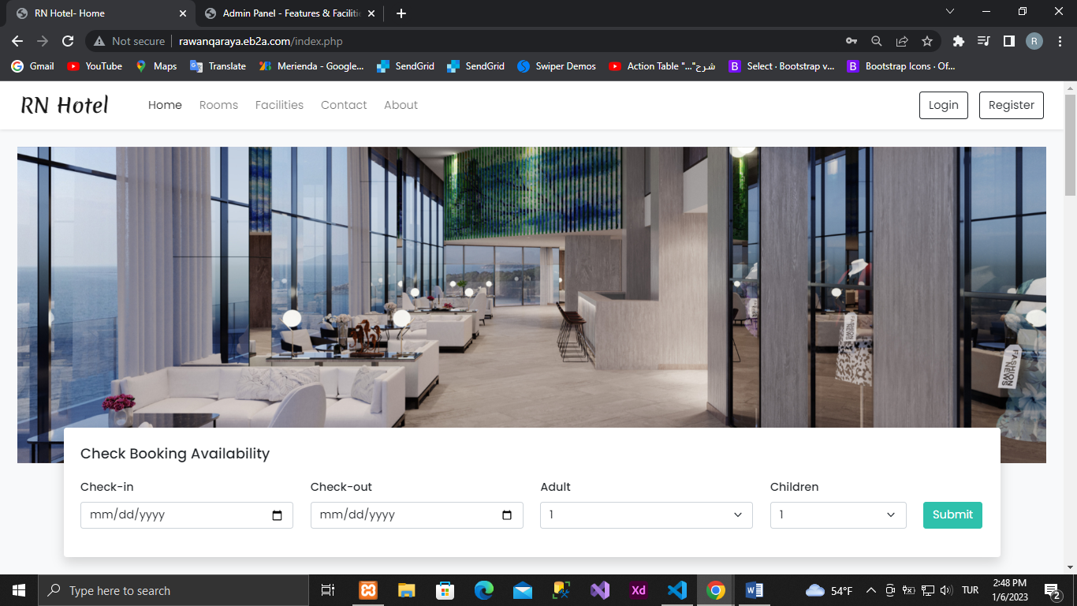

1. Settings  
     
   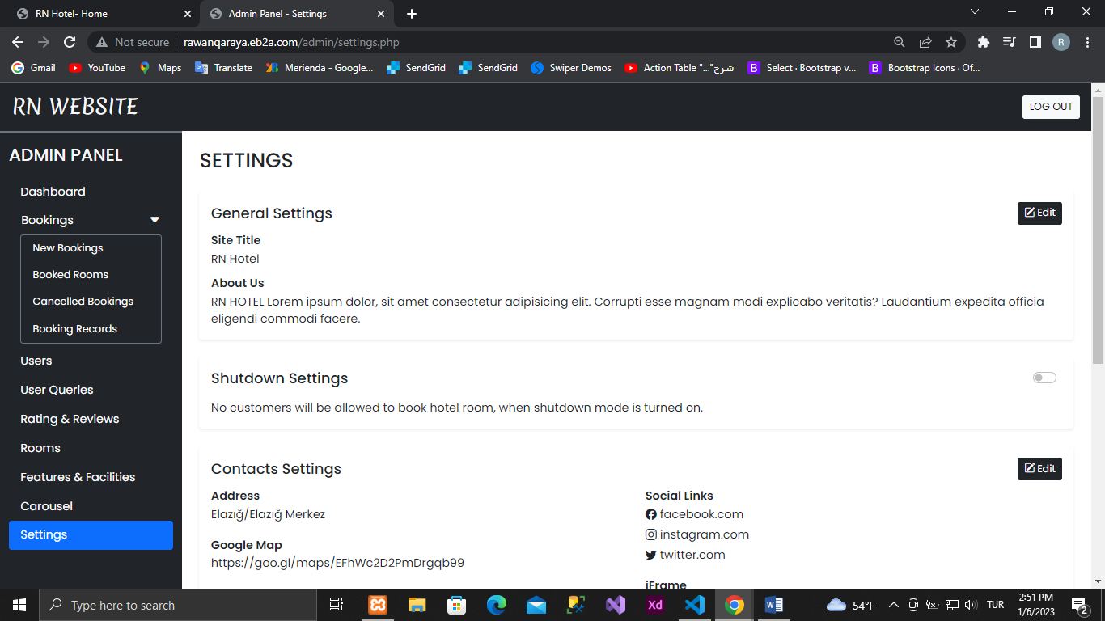

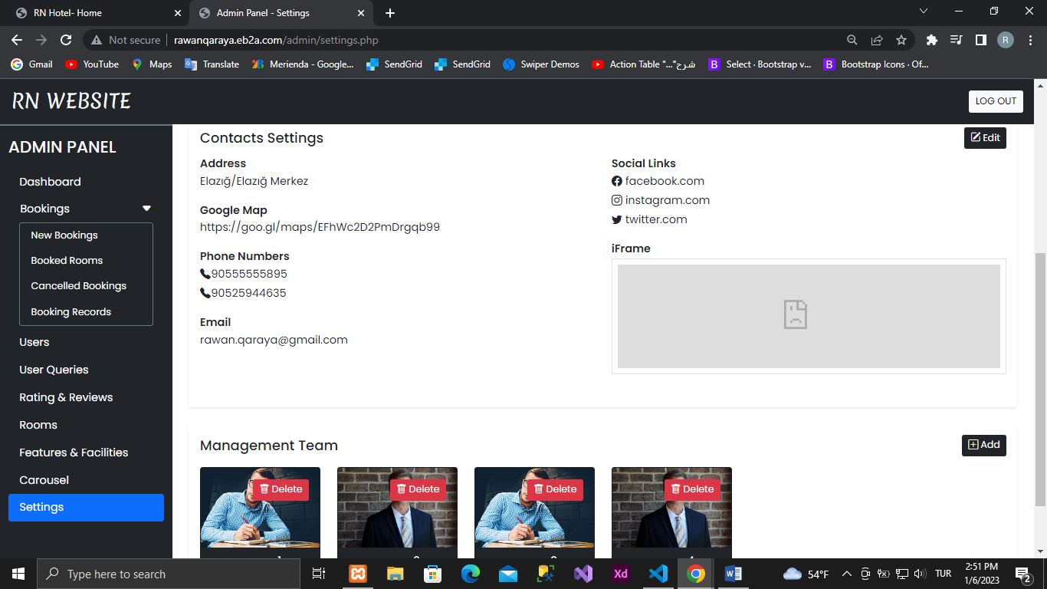



We can change the website name from here

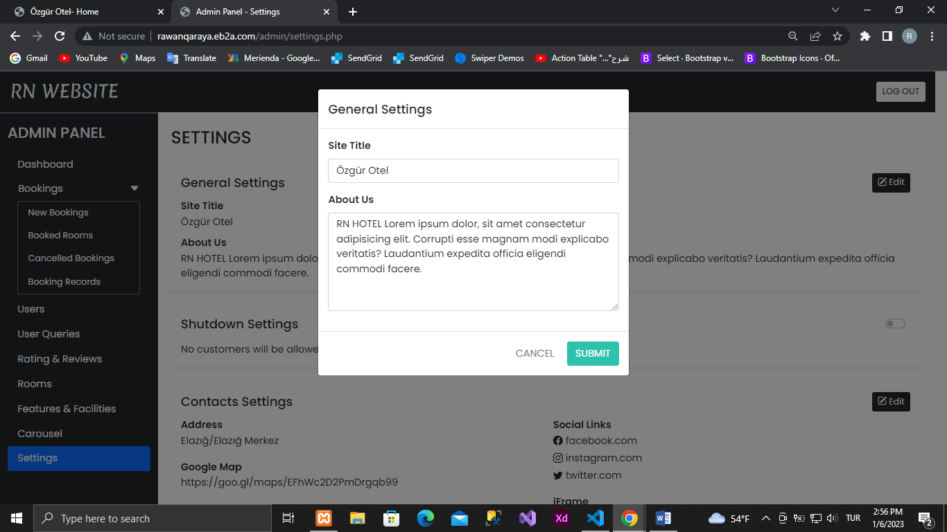

The result is like this

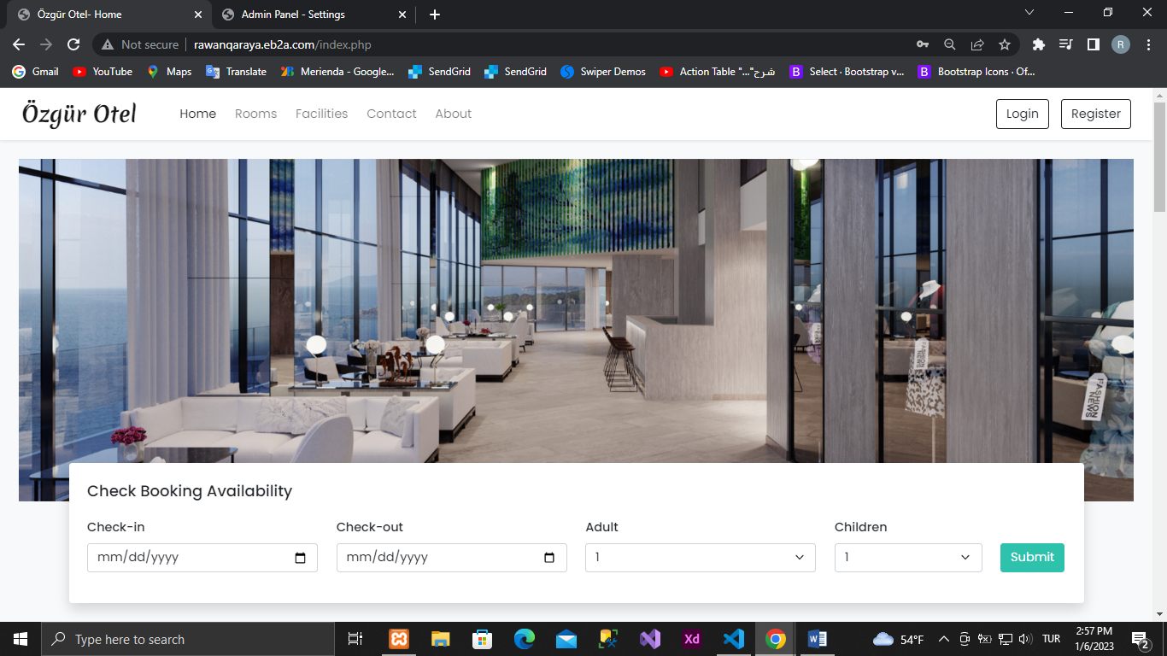

To close the site (if there are any transactions on the site) we can close it from here  
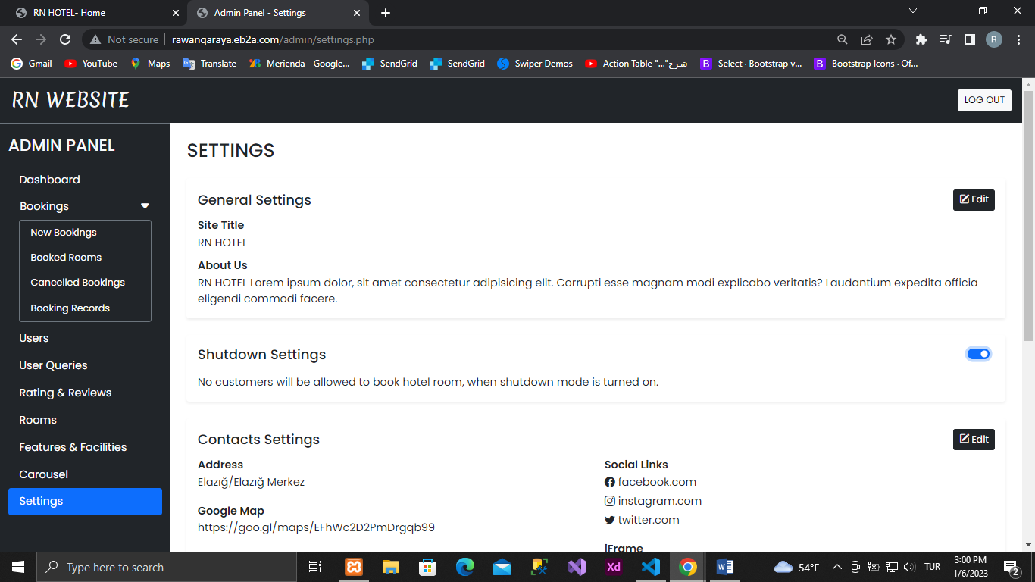

The result is like this  
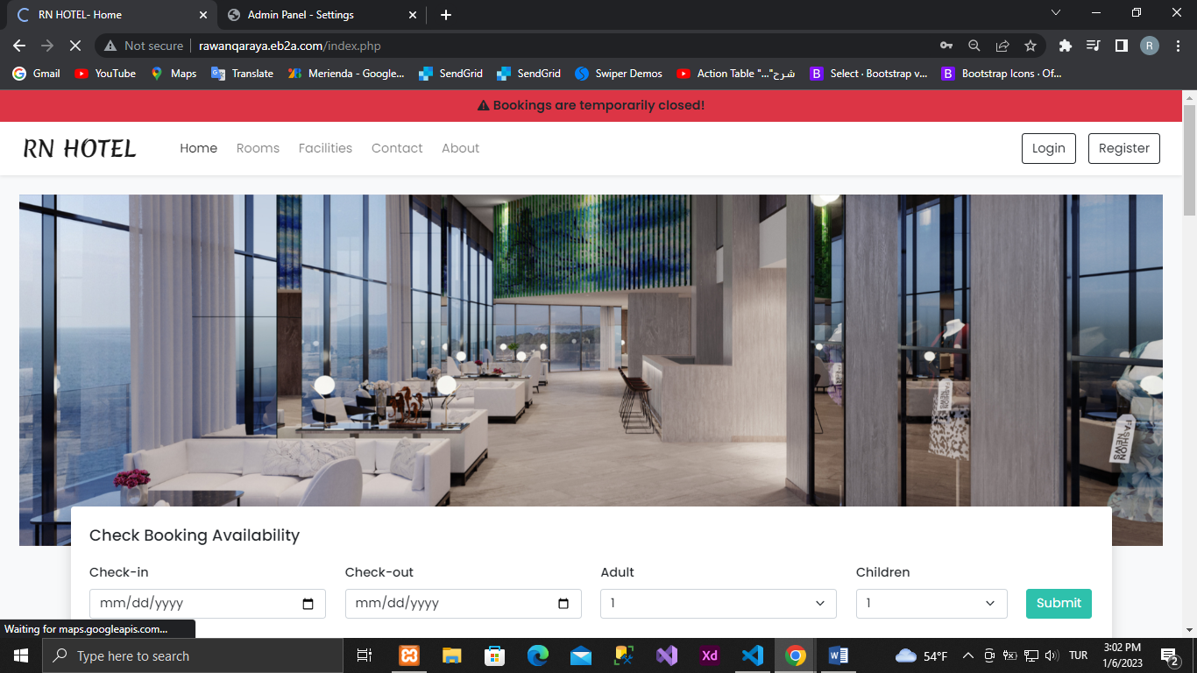

We can't reserve a room

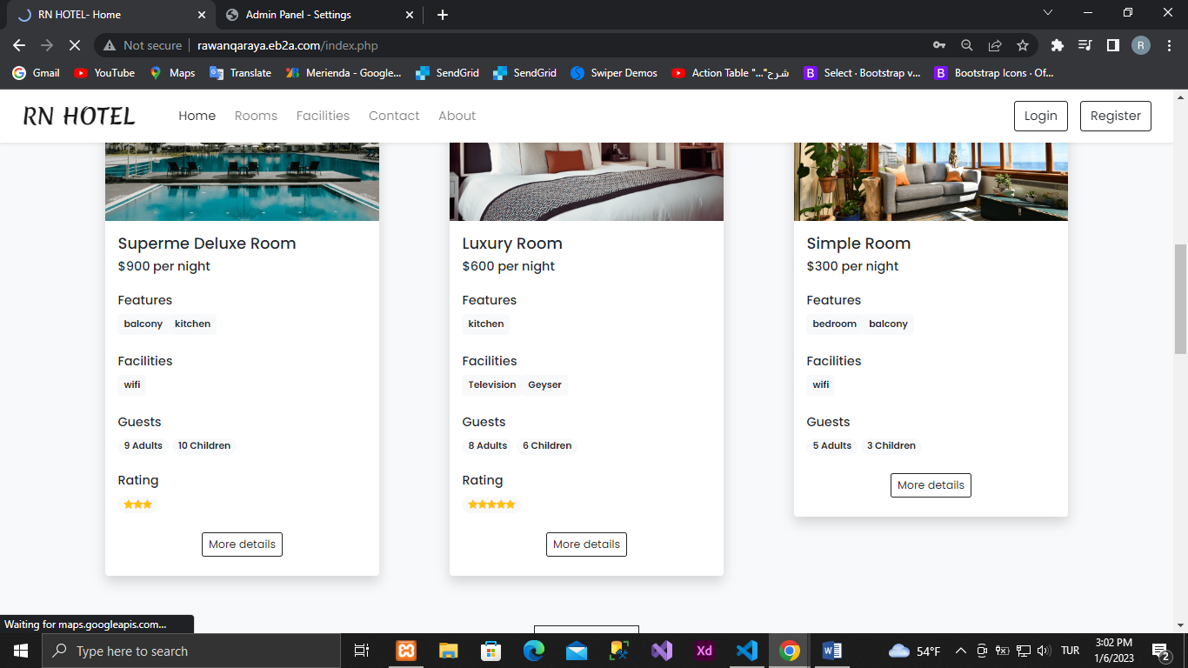

Contact us we can update from here

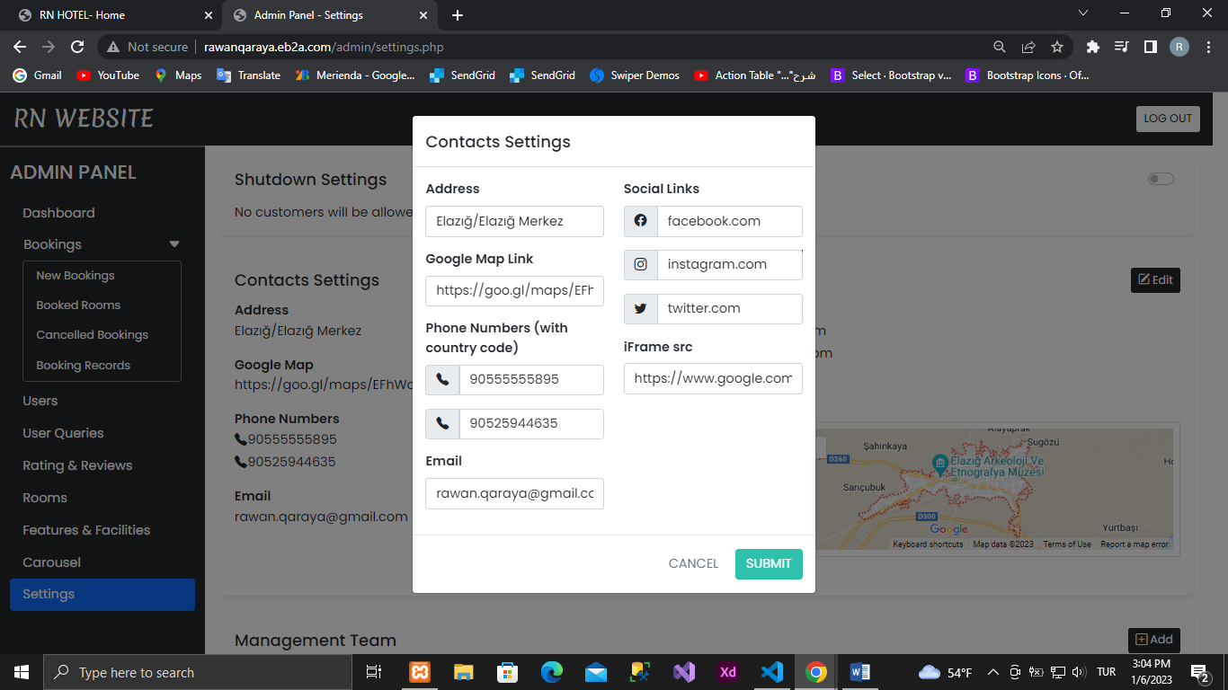

For the management team  
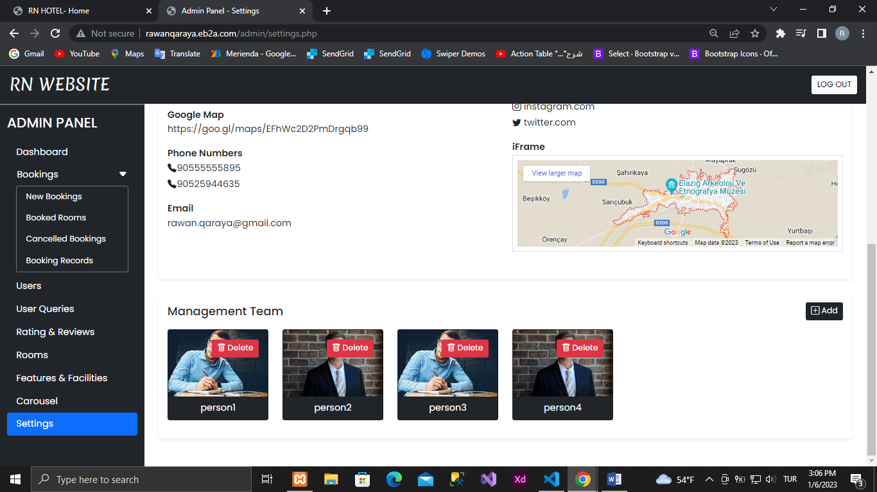

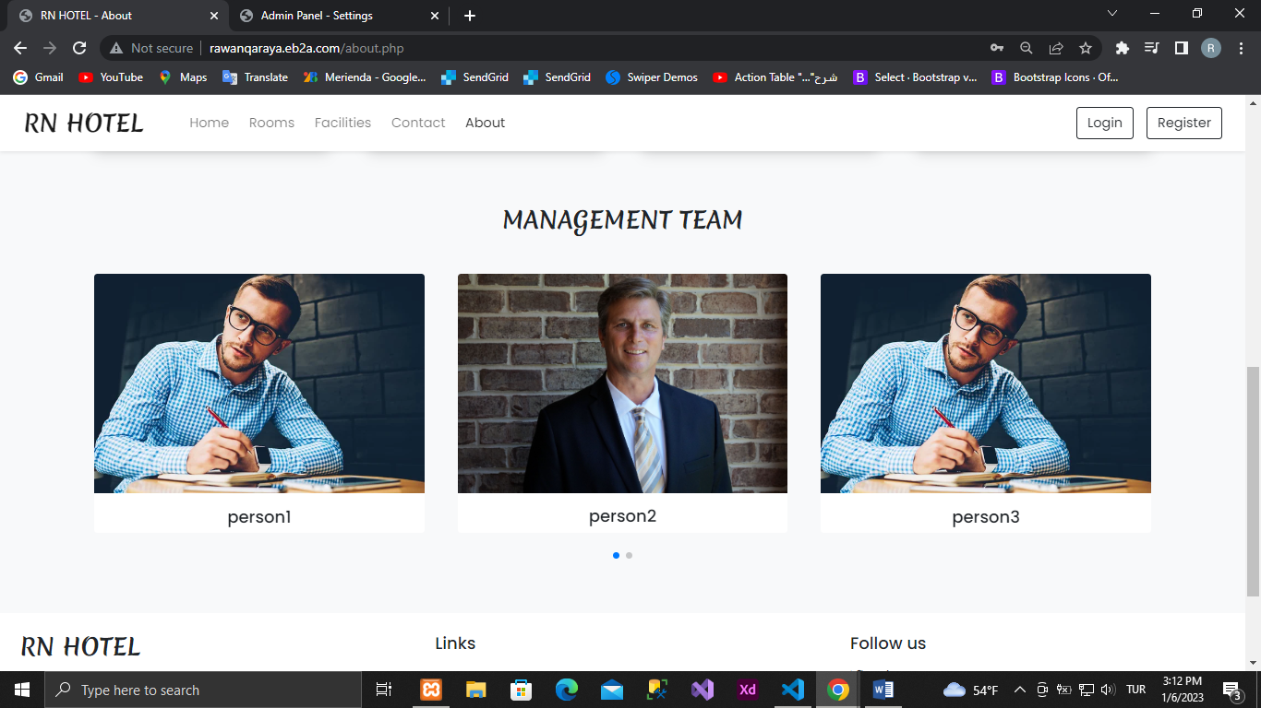

**The most important Codes:**

to connect to the database

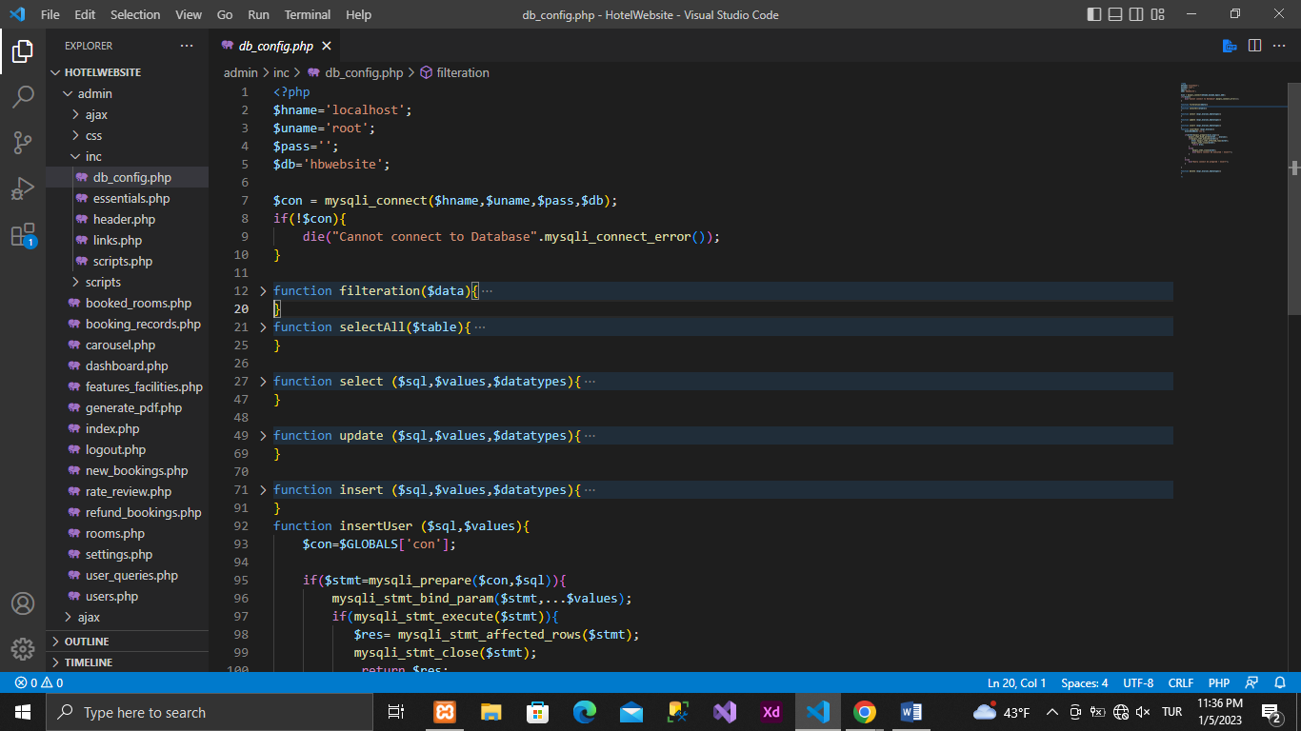

select from table function

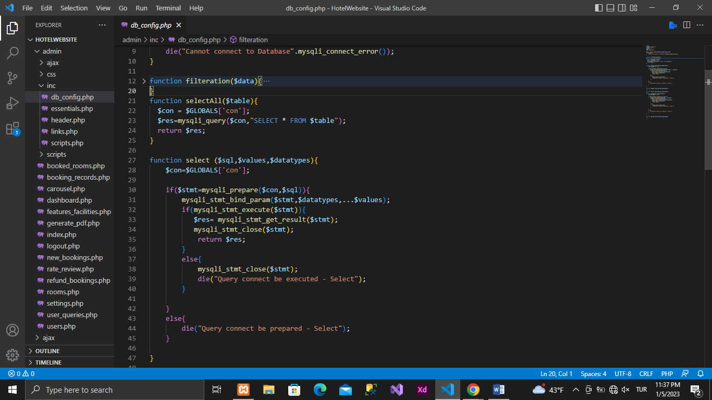

update on table function

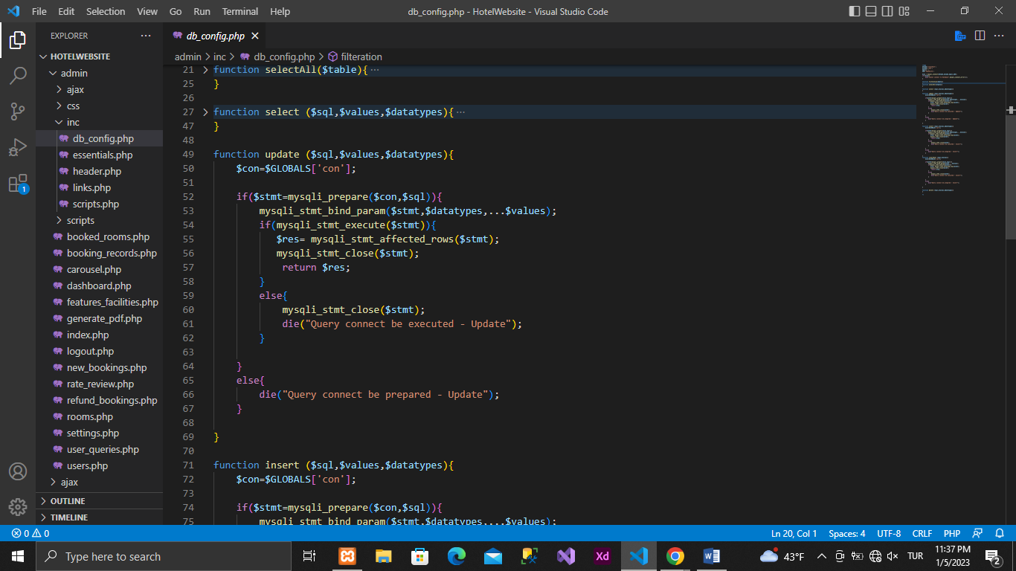

function to insert into table

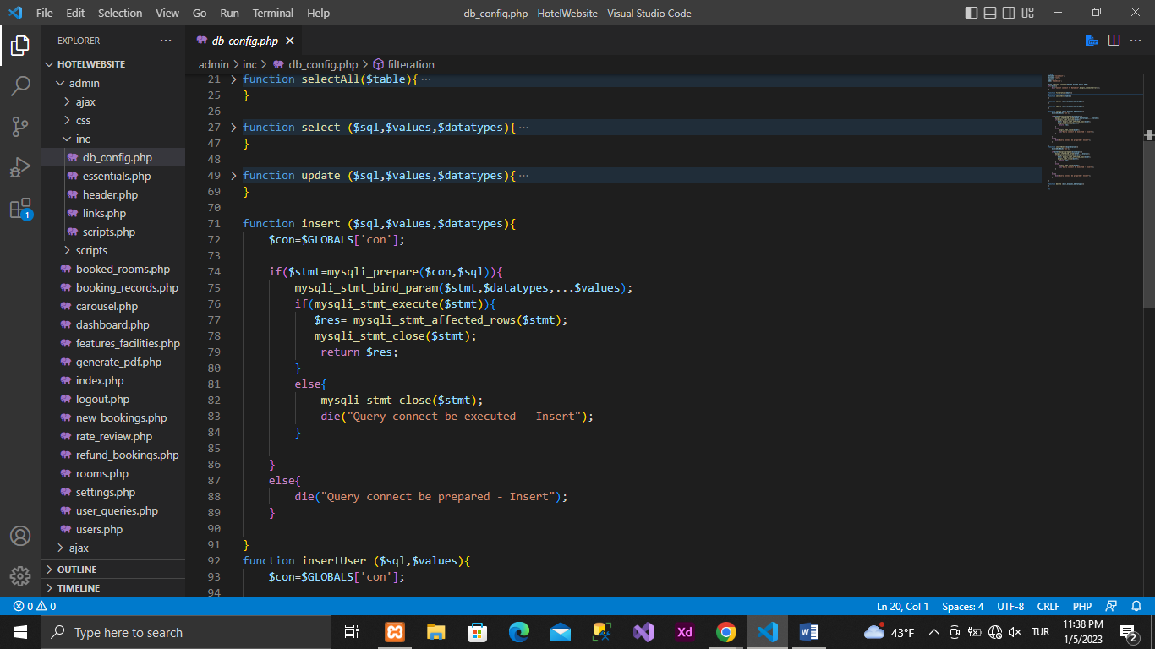

function to add user to table

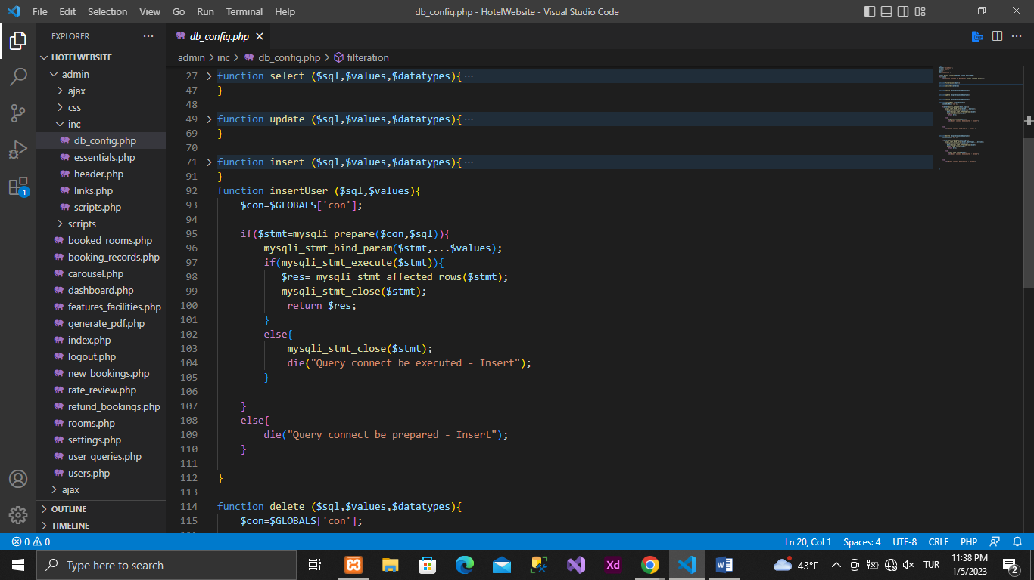

delete from table function

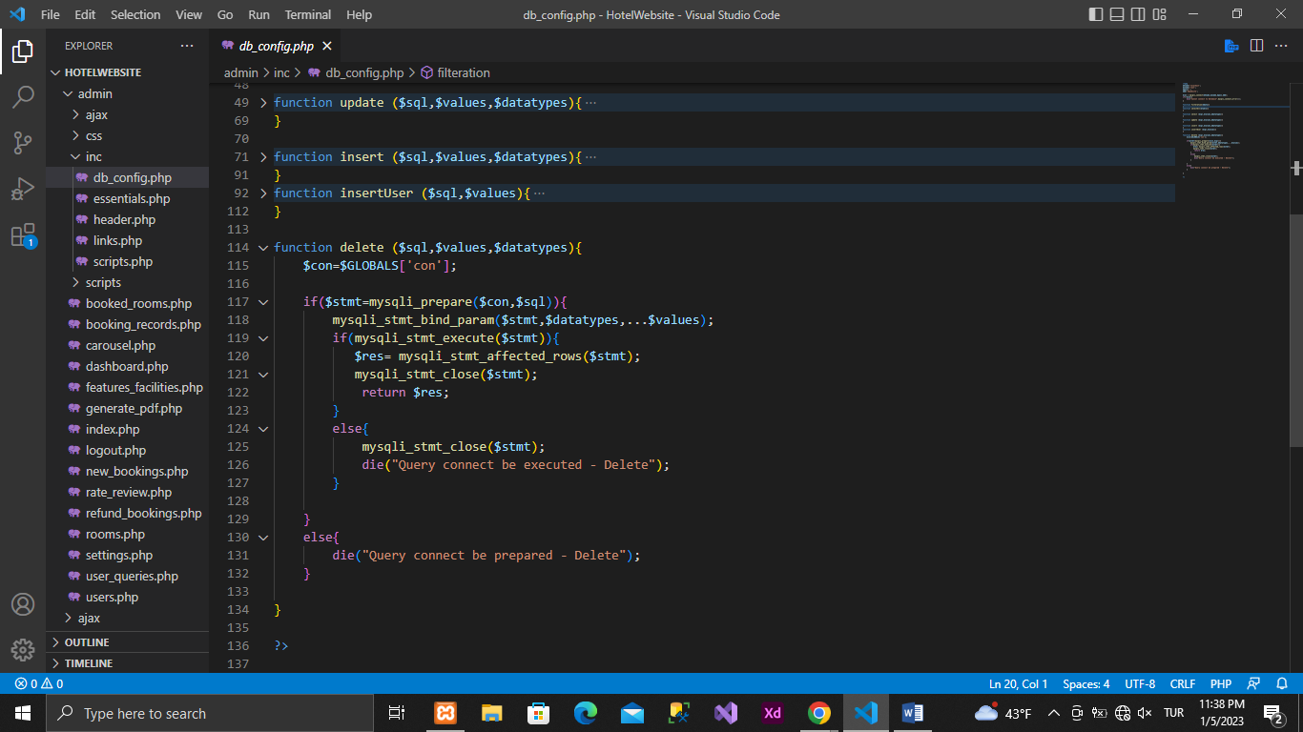

Admin to log in

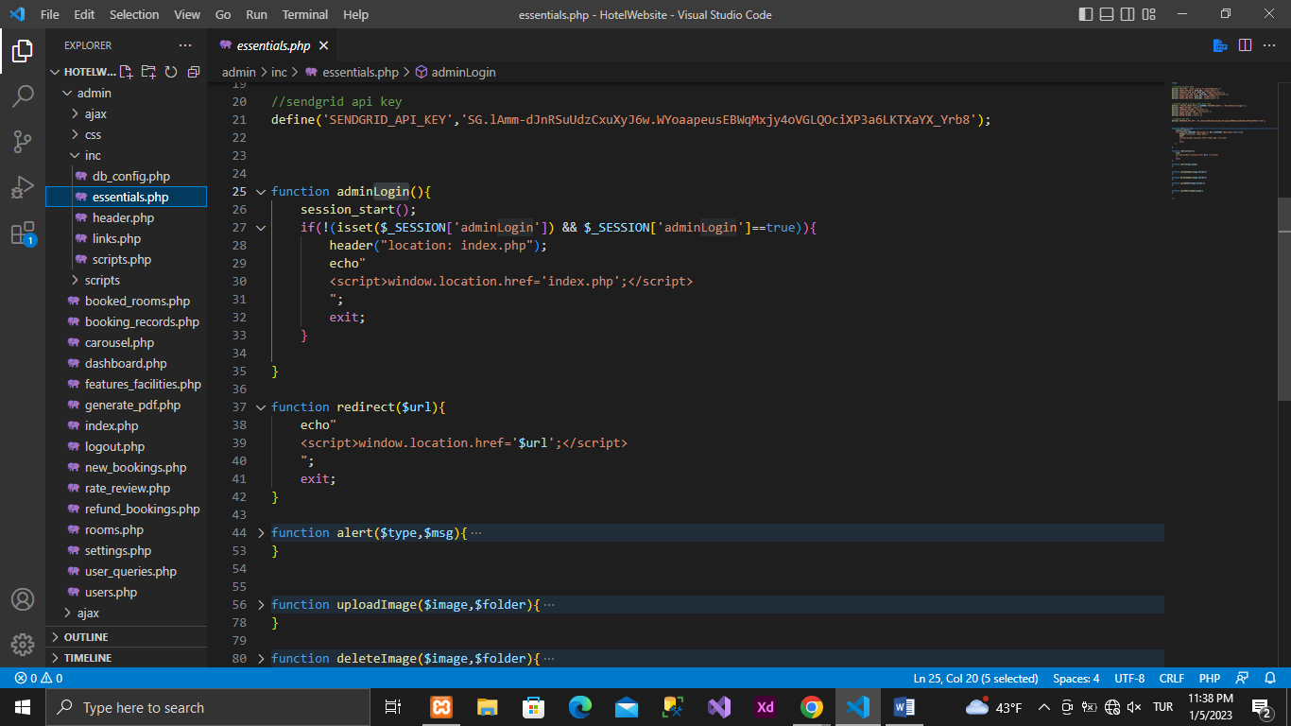

image upload function

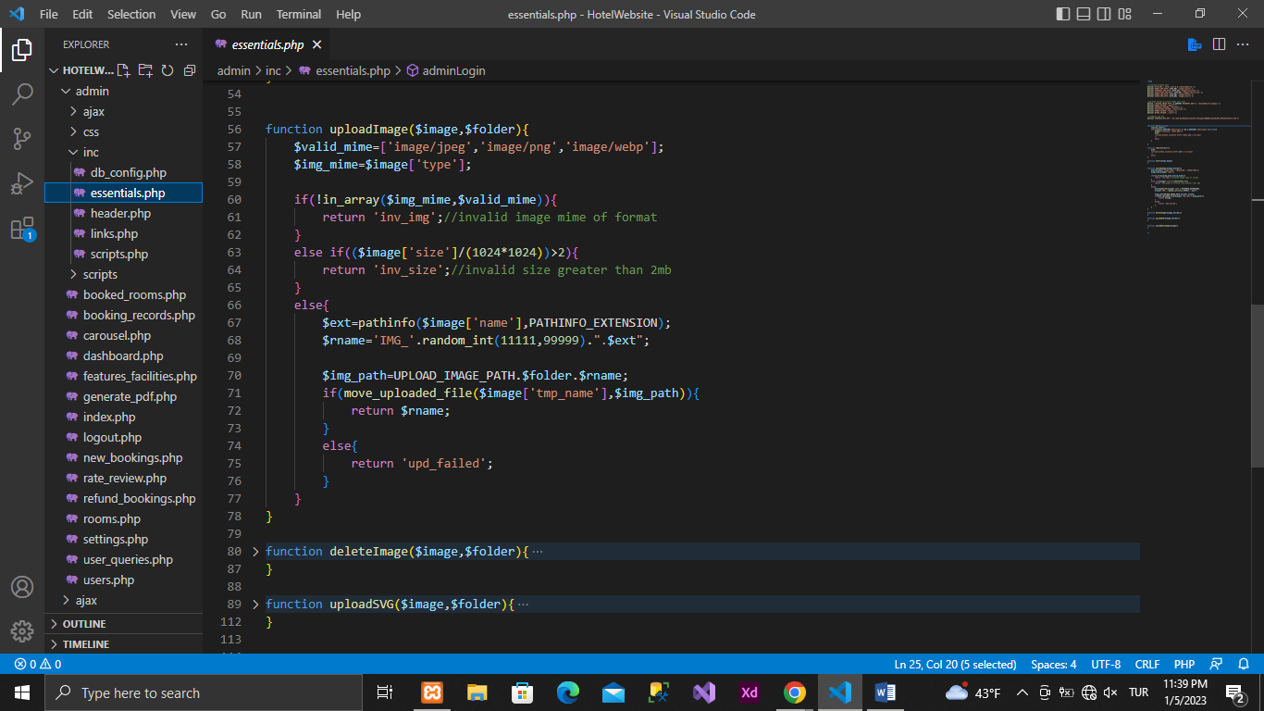

image delete function

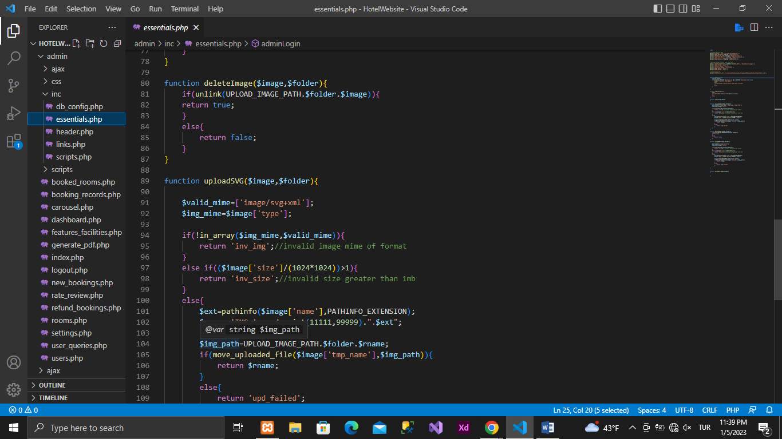

To show the most rated rooms and most booked rooms on the dashboard

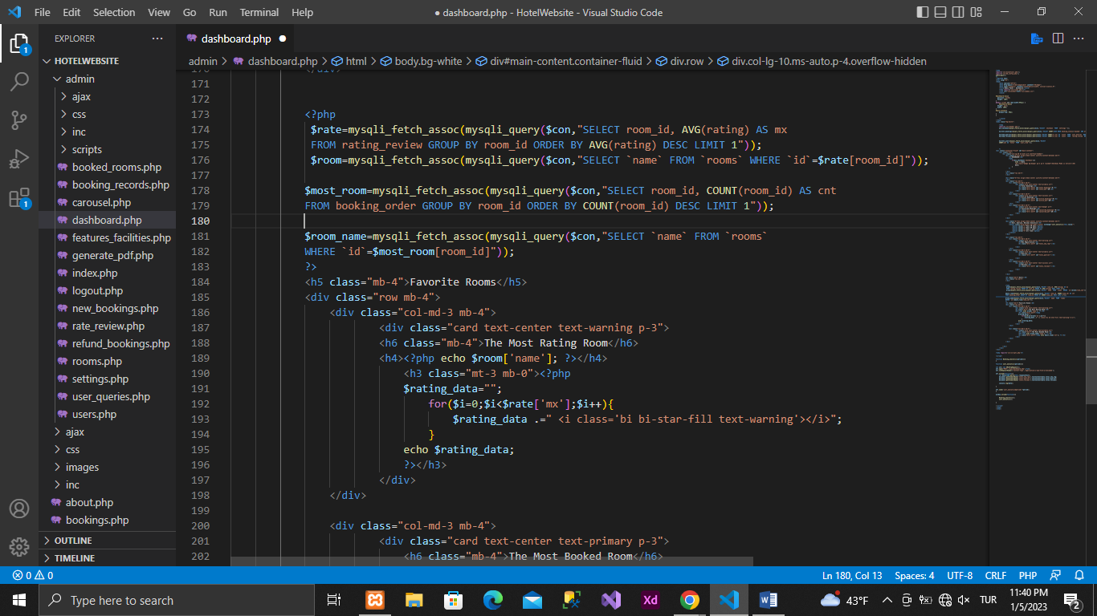

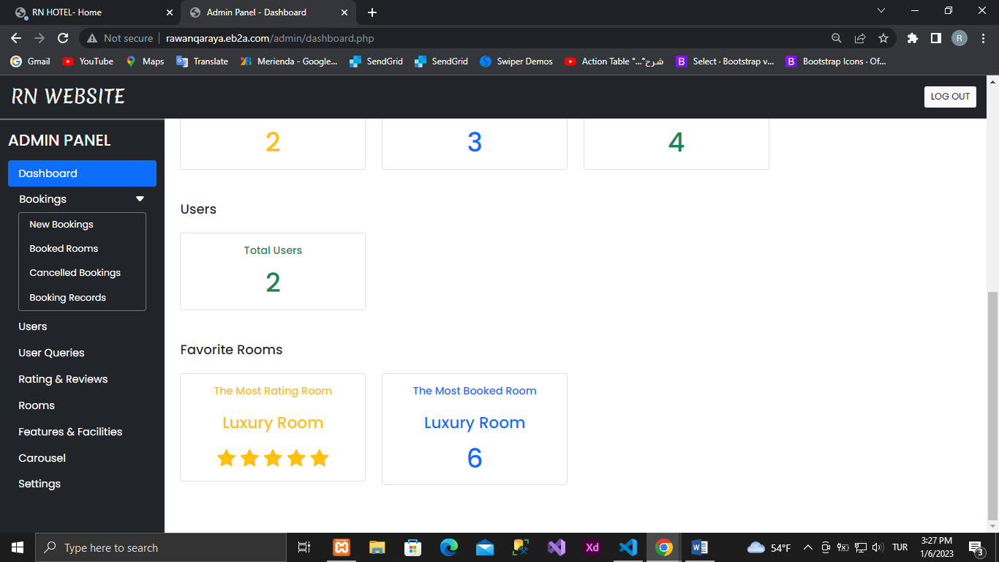

Sign up

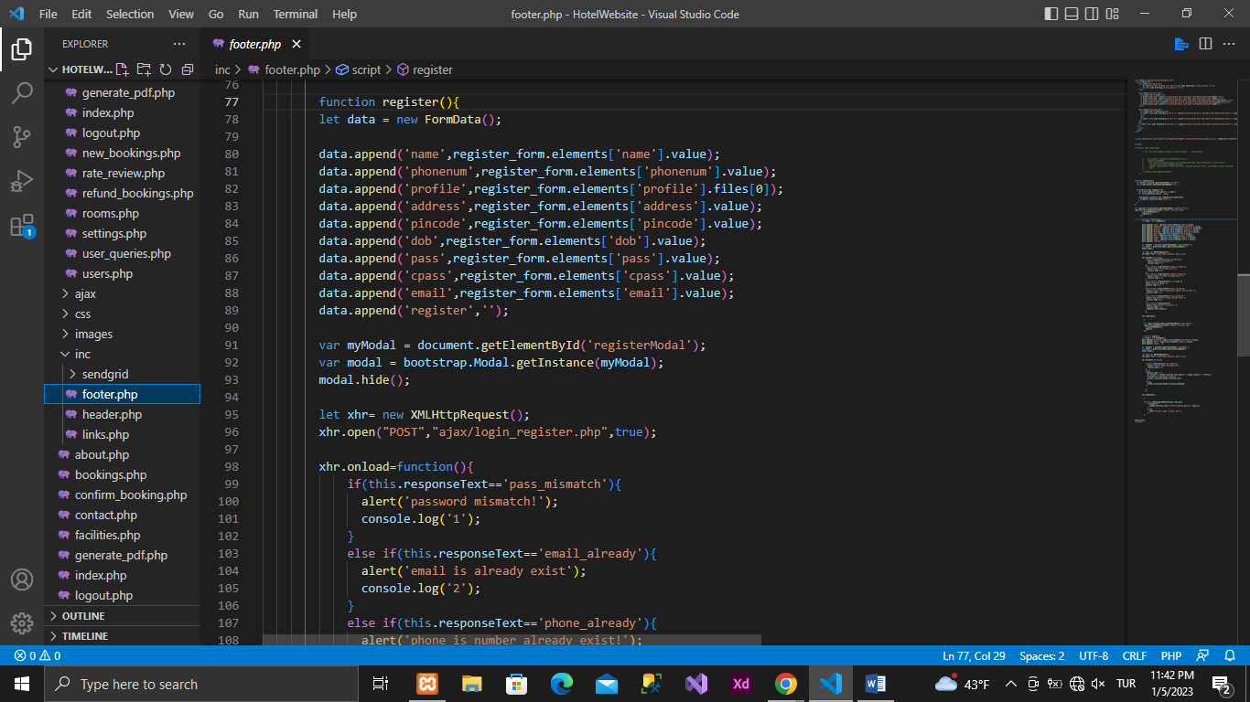

To log in

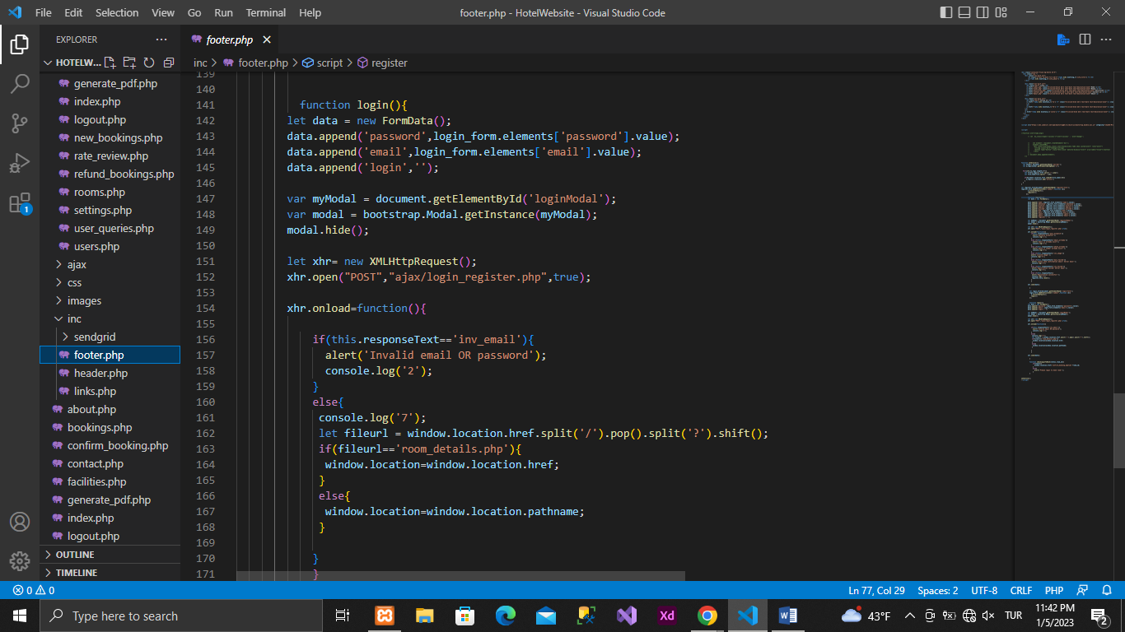

**Website Link**

|  |
| --- |
| **User Login :**  <http://www.rawanqaraya.eb2a.com/index.php>  e-mail: [rawan.qaraya@gmail.com](mailto:rawan.qaraya@gmail.com)  password: 1 |

|  |
| --- |
| **Admin Login :**  <http://www.rawanqaraya.eb2a.com/admin/index.php>  Username: rawan  password: Rr123 |